**POSİTİON PAPER**

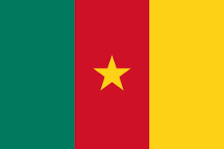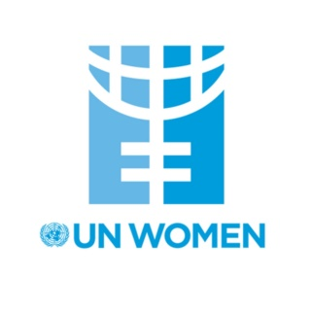**Committee: United Nations**  **(UNWOMEN)**

**Country: REPUBLIC OF CAMEROON**

**Agenda Item:** Addressing Femicide Through Legislative Action and International Cooperation.

The government of Cameroon has developed and implemented various policies on gender equality and women's rights. However, there are some difficulties regarding the effectiveness and sustainability of these policies. The measures taken in the fight against violence against women are insufficient, as Cameroon, we wish that we can solve this problem.

Women around the world are still very much treated as second class citizens. Discrimination affects women in various aspects like in education to labor force and politics. There are issues of violenc, harassment, sexual harassment and home abuse. Even today in the world, girls are unable to acquire education. In numerous societies, womenhave limited participation in public life owing to traditional and cultural norms. And by challenging those norms, Cameroon aims to enable women to fight for themselves.

Cameroon women have many women´s workforce but many times less that men´s access to the labor force. Likewise, politics and education sectors are just like it- In this context. Adding on this the Federal Government of Cameroon 2011 adopted the national Policy on Gender Equality(NGPC). The policy is supposed to provide an enabling environment for the full enjoyment of women rights in areas related to social, economic and political. The country observes a ''16 Days of Activism- Campaign against violence against women and girl" every year in Cameroon. Various events such are included in the campaigns to highlight the issue of sexual harassment on campuses and let victims be heard.