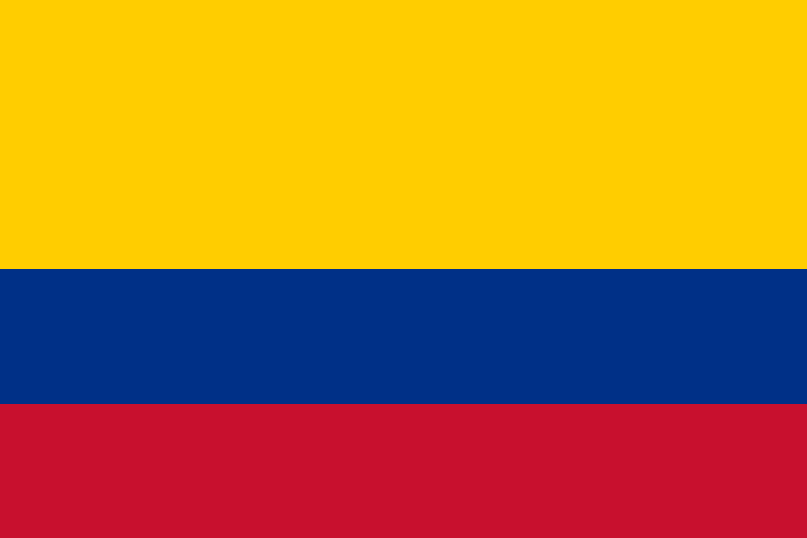 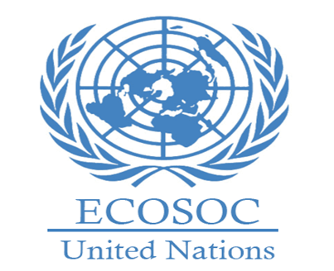

**Committee**:The Economic and Social Council(ECOSOC)

**Country**:Colombia

**Agenda Item**:Promoting Gender Equality and Empowering Women in Developing Economies.

Colombia, officially the Republic of Colombia, is a country located in South America and has islands in North America.It is the 4th largest country in South America and the 26th largest country in the world by area. With a population of over 50 million.Indigenous civilizations, European settlers, African slaves, and immigrants from Europe and the Middle East form the sources of the country's rich cultural heritage.

Women in Colombia have the right to equal pay with men. Women have full rights to establish and run their own businesses. Women have the right to access education and vocational training. In order to achieve gender equality, women are targeted to take a more active role, especially in the agriculture, trade, technology and service sectors.

Colombia could establish an institution and private financial support program to better gender equality. Women would be taught basic subjects such as marketing, e-commerce, accounting, and this would also have an impact on the country's economy.Seed fertilizer and equipment support can be provided to women farmers working in rural areas.Prejudices in society can be broken and new perceptions can be created with documentaries,campaings and social media projects that tell about the success of women in business life.