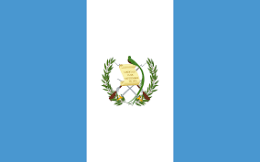
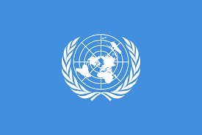
Addressing Femicide Through Legislative Action And International Cooperation

Conference: ETUTRAIN’25
Country: Guatemala
Committee: UNWOMEN
Delegate: Adnan Yusuf DAYI

The Republic of Guatemala is a country in Central America which is bordered by Mexico, Belize, Honduras and El Salvador. Capital city is Guatemala City and most of Guatemala's people consist of Indigenous people. This is why the femicide committed due to racism is an important problem for Guatemala. Official language in Guatemala is Spanish and nearly half of the population is Europe-originated. Guatemala has a population of 18 millions and the male/female ratio is 0.98.

Femicide is unfortunately a significant problem in Guatemala. Sorry to say but The Republic of Guatemala is the third country with the highest femicide rates in the world, after El Salvador and Jamaica. But this is not a coincidence. Femicide is already one of the greatest problems of Latin America and especially Central America. It has several causes and one of them is the “Machismo” culture in Latin America. Machismo is a Belief that expresses the superiority of men and thinks that men are always at a higher level than women. This became a cultural norm especially in Central America and this belief is a great supporter of femicide.

Inadequate punishment for femicide is another great supporter of femicide in Latin America. Most of the Latin American countries don’t recognize femicide as a high degree crime and it has lower degree punishments in some situations like romantic relationships. Excluding some kinds of violence against women in marriage encourages the potential criminals and this is why the femicide rate is higher in Latin America.

But finally, We can say that there is a hopeful table we see in Guatemala. Because after the hard days of civil war, there are too many new laws supporting the combat and punishing against femicide. Even though the rate is unfortunately still high, modern culture and feminist movements are influential in Central America nowadays. Even if we have to do too many things like educating new generations and increasing the punishment levels for femicide, the table is generally hopeful compared to the past. So we extremely support the combat against the femicide in Guatemala and we believe that the table will be better.

Sources

Atske, S., & Atske, S. (2024, December 17). What U.S. Latinos say about ‘Machismo.’ Pew Research Center. https://www.pewresearch.org/race-and-ethnicity/2024/12/17/what-u-s-latinos-say-about-machismo/#:~:text=U.S.%20Latinos%20define%20machismo%20in%20many%20ways.&text=25%25%20say%20machismo%20is%20the,in%20society%20based%20on%20gender.
Guatemala - the World Factbook. (n.d.). https://www.cia.gov/the-world-factbook/countries/guatemala/
Open Knowledge Repository. (n.d.). https://openknowledge.worldbank.org/entities/publication/4e23653e-6941-434a-860b-acb558b1df56
Piette, C. (2015, December 5). Where women are killed by their own families. BBC News. https://www.bbc.com/news/magazine-34978330
Sergi, A. (2020). Monica Massari and Vittorio Martone (2019) ‬Mafia Violence: Political, symbolic, and economic forms of violence in Camorra Clans‬. Great Britain: Routledge. International Journal for Crime Justice and Social Democracy, 9(4), 215–217. https://doi.org/10.5204/ijcjsd.1399
Un modelo de Vida - DON FERMIN TANG�IS. (n.d.). https://web.archive.org/web/20080512063013/http://www.ftanguis.edu.pe/modelodevida.html

