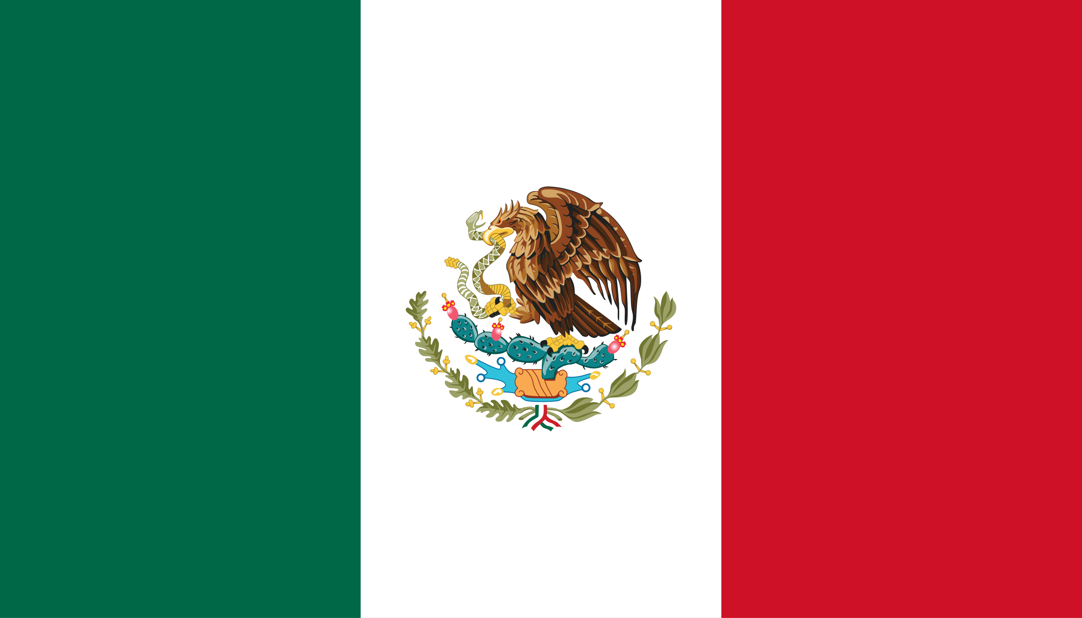Commitee:The Social, Humanitarian and Cultural Commitee

Country:The United Mexican States

Delegate:Öykü Meriç

Agenda Item:Accomplishing Freedom of Press and Protection of Journalists Within Conflict Zones

The protection of journalists ,particularly within conflict zones, is a pressing issue as access to information is an essential right in a democratic society. As the press plays a significant role in informing the public, achieving an independent press is curicial, especially in times of war. According to UNESCO, attacks against journalists often go unpunished, especially in conflict zones. Several journalists are abducted, tortured and murdered every year globally. The delegate of Mexico recognizes that accomplishing freedom of press and protection of journalists has to be taken seriously. Mexico acknowledges that ensuring reliable access to information, a significant factor in maintaining a democratic environment, has to be aproached with immediance.

Over the past decade, Mexico has faced its own challenges with violence against journalists, often in the context of organized crime, which includes cartels within the region. In response, the Mexican Government developed new policies to protect the rights of journalists such as, the Mechanism for the Protection of Human Rights Defenders and Journalists (FEADLE), which was created in 2012 by the Mexican federal government to cease violence against journalists. Amnesty International and the Committee to Protect Journalists (CPJ) also began working on a joint project to determine areas of opportunity to improve the Mechanism for the Protection of Human Rights Defenders and Journalists, the country’s legal and institutional framework to protect journalists at a more advanced level. At a more international level, Mexico has supported UN Security Council Resolution 2222 since 2015, which highlights the protection of journalists in war zones.

Mexico urges the United Nations to prioritize comprehensive policies, such as funding an organization that gives legal training and provides protection workshops for reporters who intend to work in conflict zones. This kind of organization aims to train journalists so they can defend themselves up to an extent when faced with attacks, as many journalists are forced to work in conflict zones without any formal protection. Establishing a global protection program can also be useful as similar programs exist for human rights activists. Mexico recognizes this approach towards this problem and aims to disable the groups and individuals that attack reporters. By working together, the global community can create solutions that protect the rights of journalists and accomplish press freedom.

Sources:

<https://www.amnesty.org/>

<https://cpj.org/>

<https://www.unesco.org/en/safety-journalists>

<https://undocs.org/S/RES/2222(2015)>

<https://cpj.org/2018/01/mexicos-special-prosecutor-says-feadle-is-improvin/>

<https://www.google.com/amp/s/www.bbc.com/news/world-latin-america-39436568.amp>

<https://www.google.com/amp/s/www.bbc.com/news/world-latin-america-60227982.amp>

<https://www.google.com/amp/s/cpj.org/reports/2017/05/no-excuse-mexico-federal-protections-feadle-threat-sidebar/amp/>

<https://rsf.org/en/country/mexico>

<https://www.gob.mx/segob/acciones-y-programas/mecanismo-para-la-proteccion-de-personas-defensoras-de-derechos-humanos-y-periodistas>