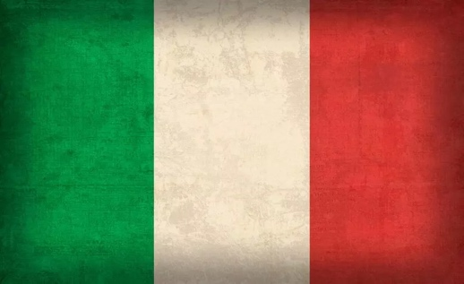Committee: Special Political and Decolonization Commitee. Country: Italy

Delegate: Buğlem Polat

Agenda Item: Govermental Stabilization after the Bangladesh

Political Crisis

The Italian Republic is a remarkable country which is located in the Southern Europe, it’s the center of the Mediterranean both pyscially and touristy. It’s also like a bridge between Europe, Africa and the Middle East. Italy has a strong connectioan with both Europe and developing worlds when it comes to the historical, economic and cultural ties. As a founder member of the European Union, a member of the United Nations and the G7 Italy holds a firm commintment to international peace and the promotion of democratic values ​​​​around the world. In addition, Italy holds a multilateralistic attitude in foreign policy too. Italy does not shy away from its responsibility to contribute to political stability and democratic resilience, especially in regions experiencing crisis, and its past actions show that Italy is ready to provide all kinds of humanitarian assistance when it’s needed.

The Bangladesh Crisis is not just a simple protest. It’s a revolution which consists with the Bangali people’s rage. Events from 1857 to 1947, called the “Indian Independence Movement” which aimed to end the British Colonial Rule provided the territory of the South Asia region to gain independence and split into two sovereign countries: India and Pakistan. As a result of internal unrest within Pakistan, the country was divided into two parts, East and West, with the 1971 Bangladesh Liberation War. The protests began in early July as peaceful demands from university students to abolish quotas in civil service jobs - a third of these are reserved for relatives of veterans from Bangladesh’s war for independence from Pakistan in 1971. The campaigners had argued the system was discriminatory and needed to be overhauled. Although their request was largely met, the protests soon transformed into a wider anti-government movement. As the movement expanded, clashes followed, and over 300 people were killed in the unrest. Bangladeshi media and protesters blamed police for the spiralling death toll. The government, though, maintained that officers only ever opened fire out of self-defence or to protect state property. While these protest were ongoing, the nation saw a huge

decline in foreign exchange reserves, leading to hard times in the importation of staple

commodities, such as fuel and food. Inflation hit new records, putting the cost of living for

the average citizen under intense pressure. To solve this problem Bangladesh has recevied both financial and spiritual supports from multiple countries. As an example, the capital of Bangladesh Dhaka received 700 million dollars of loan from IMF and 1.4 billions dollars worth of payment support from World Bank for worldwide vaccination program.

Italy and Bangladesh enjoys an excellent bilateral relation that initiated immediate after our independence in 1971. Italy recognised Bangladesh on 12 February 1972 as one of the first few countries in the world. Diplomatic relations between Bangladesh and Italy was established in 1973. In 1974, Italy was one of the countries that sponsored the admission of Bangladesh to the United Nations. Whenever Bangladesh has sought Italy's support, Italy has exhibited understanding for Bangladesh's position on various issues in the international arena. Specially, Italy has expressed clear support for the Bangladesh's position on the GSP issue and adopted a more flexible attitude with regard to knitwear import from Bangladesh.

Although positive discrimination can be beneficial in some areas, it is a sensitive issue that needs to be managed according to the public's reaction. The fact that the public can protest shows that they are developed enough to express themselves. It is important for the public to respect this constitutional right and for the state not to insist on it, in terms of social peace and economic prosperity.

SOURCES:

<https://rome.mofa.gov.bd/en/site/page/Bilateral-Relation-Italy---Bangladesh>

<https://www.bbc.com/news/world-south-asia-12650940>

<https://www.bbc.com/news/articles/c4ng5v03gd4o>

<https://www.bbc.com/news/articles/cq5xye1d285o>