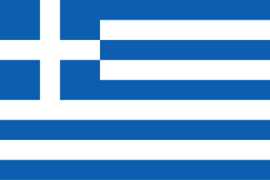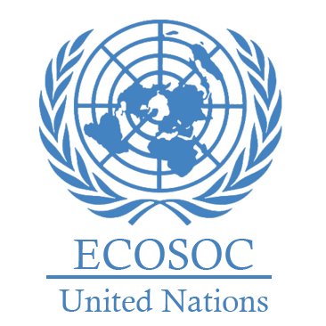

Country: Greece

Committee: ECOSOC

Topic: Promoting Gender Equality and Empowering Women in Developing Economies.

Position Paper – Greece

Greece is a country in Europa. Its capital city is Athens. The population is about 10 million. The area is 131.957 square kilometers. Greece believes that gender equality is a main human right and an important aspect of social justice. In many developing countries, women face difficult challenges. These challenges include barriers to education, employment and personal security. Many girls cannot attend school because of cultural norms and social pressure. Greece recognizes these challenges and supports women in business. As a member of the European Union, Greece works with international groups like the United Nations. This helps Greece match its laws with global goals for gender equality. By supporting girls, education and women’s jobs. Greece helps its people and also supports gender equality around the world. Greece believes that empowering women makes countries stronger.

To formalize loyalty of gender equality Greece puts into action the National Action Plan for Gender Equality (2021-2025). This comprehensive plan outlines specific strategies to fight Stop violence against women, help more women get jobs, and support women in politics. Greece wants to build a place where women can live safely and equally, without fear or unfair conditions. In 2019, Greece passed Law No. 4604 to fight discrimination against women and give them equal rights. This law protects women at work, in schools, and in society. It helps stop unfair treatment based on gender. By doing this, Greece shows it supports gender equality and does not accept discrimination. This law is important to build a culture where women are respected and treated equally. Greece also has groups like KETHI (Centre for Research on Women’s Issues). KETHI studies the problems women face and gives advice to the government. It helps improve policies and find better ways to support women. Greece works to rise gender equality through national laws, research, and international cooperation. One of the important organizations is KETHI, which studies women's issues and helps the government create better policies. This connection between research and policy helps Greece find real solutions to gender inequality. Greece also works with UN Women to support women in other countries. By sharing ideas and resources, Greece supports gender equality on a global level.

Greece has three main strategies: Support for Education and Jobs: Greece gives money for girls’ education and helps women find jobs. This helps women become more independent. Fighting Violence in Communities: Greece works with local groups to stop violence against women and change harmful attitudes. Digital Skills and Business Support: Greece offer digital training and helps women start small businesses, so they can succeed in today’s economy. In conclusion, Greece believes that empowering women is key for peace, growth, and a fairer world. It’s the basic necessity for being human. Helping women helps everyone.