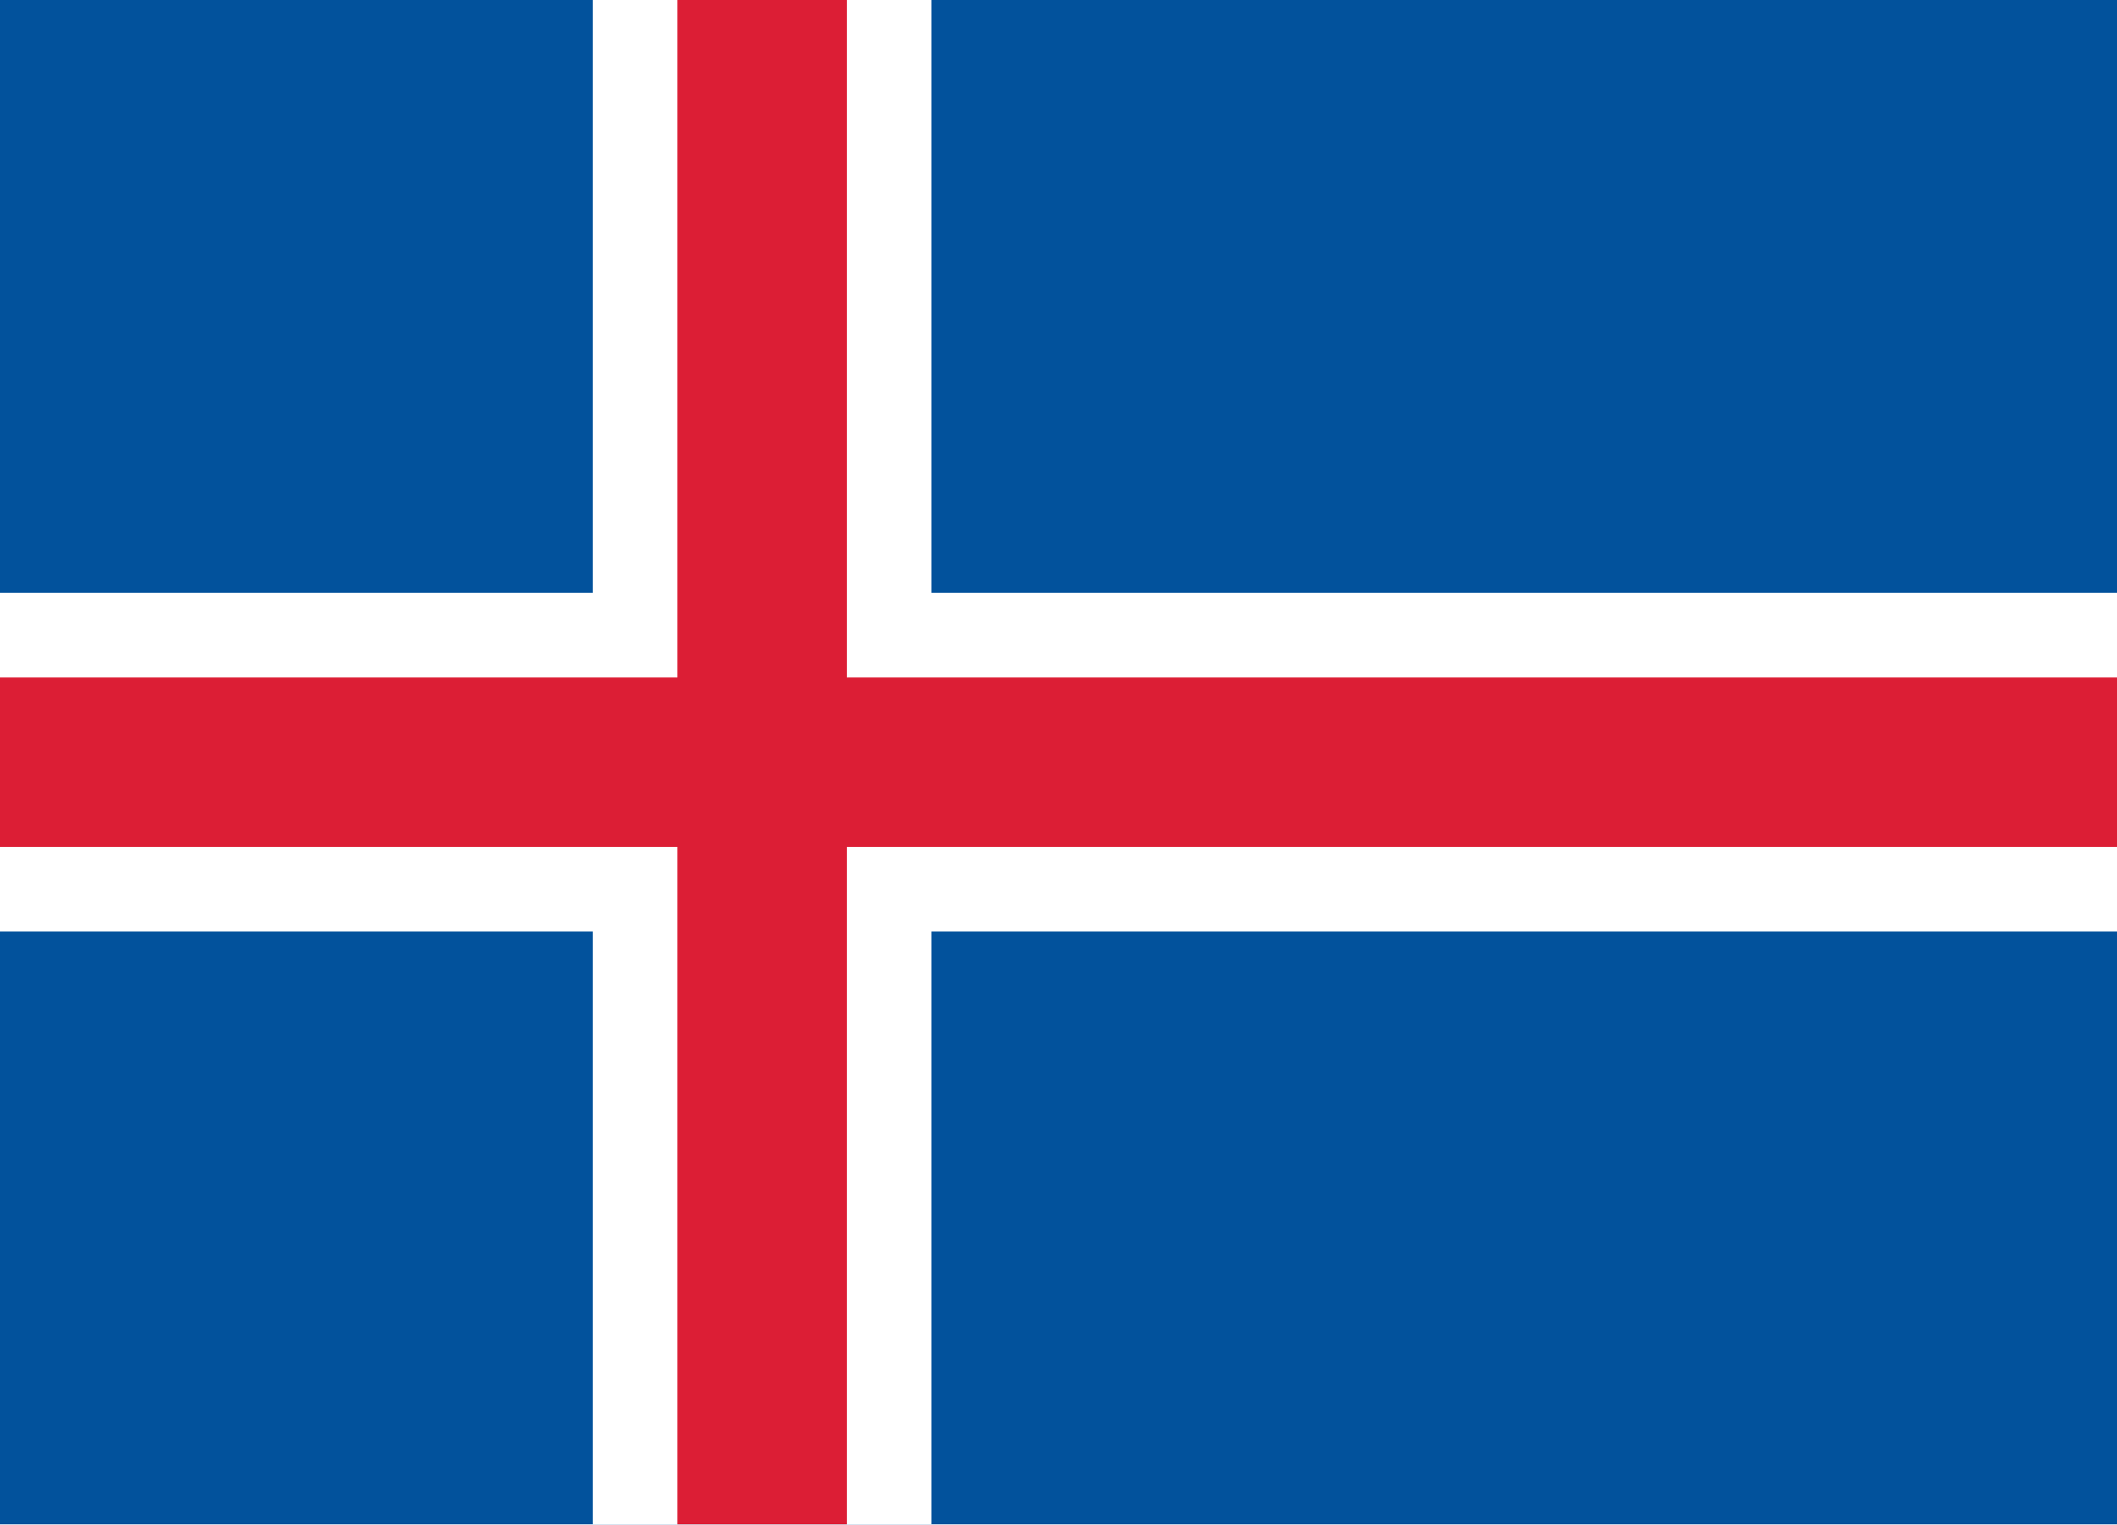Republic of Iceland

Committee: SOCHUM Committee

Topic: Accomplishing Freedom of Press and Protection of Journalists within Conflict Zones

Accomplishing freedom of the press is a global and critical complication that concerns all the nations closely. Unfortunately in 2024, 104 journalists were killed. Around the world censorship and legal pressure increased. Which obviously shows that we need to cooperate and make amendments to enhance ourselves to decreasing the pressure and death rates.

As the Republic of Iceland we are aware of this complication. That is why we are taking precautions on this issue like legal protection for journalistic sources, increased transparency and public access to information, strong protection for “whistleblower“s, no internet censorship and online content can be freely published and accessed,and more.

Representing the Republic of Iceland in this analytical committee; we can see our lacks, become aware of them and find the best solutions. We believe that we can make the world better and protect our journalist who risks themselves to reveal the truth. Our participation includes finding analytical resolutions and making legal arrangements such as building an international establishment that observes journalist rights specifically and maybe collects donations or funds to use on them.

**Bibliography:**

https://www.ifj.org/media-centre/news/detail/article/104-journalists-killed-this-year-according-to-the-ifj

https://kkc.com/blog/iceland-passes-first-comprehensive-whistleblower-law/