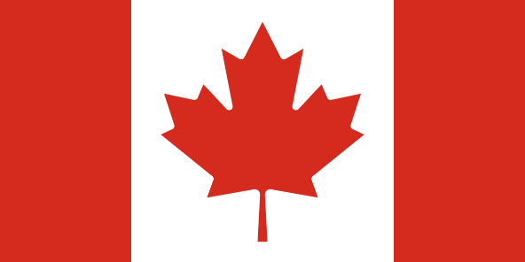 **POSITION PAPER FOR KBKMUN’25 YOUTH AND WOMEN ENPOWERMENT COMMITTEE**

**Country:** Dominion of Canada (Dominion du Canada)

**Committee:** Youth And Women Enpowerment

**Delegate:** Tufan GÜLMEZ

It is located in North America, touches the United states to the south and the Arctic Ocean to the north; Atlantic Ocean to the east Pacific Ocean on west side. Its surface area is 9,984,670 square kilometers. While it is not far from our size (only slightly larger than the United States) — second largest country by land area in the world. The capital of the nation is Ottawa. The country is mostly cold, except in the south where it features long winters and short summers and has a somewhat milder climate in the periphery regions. Currently it is ranked the 39th most populous nation in the world according to its recent statistics in 2023. To Ontario, its home has a population of 40,528,396 (74.3%), South Asian 7.1%, Chinese 4.7%, Black 4.3%, Filipino 3.5%, Arab 2.6%, Latin American 1.7%, Southeast Asian 1.3%, West Asian 1.0% and other 4.5%. It has low mortality and fertility rates, an aging population that is dwindling slowly so which makes its population pyramid stable. Commonwealth member, Canadian dollar (CAD) and it's 9th largest economy in the world. English and French are the official national languages of the country.

*Agenda Item 1: Youth’s role in advancing gender equality and women’s rights.*

Women in Canada, just like the rest of the world, have a very important role to play. Canadian youth play a big role in gender equality and women's rights. And the Government of Canada supports young people in these activities. The Government of Canada aims to bring women into society with gender equality and creates policies based on this goal.

*Agenda Item 2: Youth-led initiatives to tackle gender-based violence.*

Gender-Based violence is one of the biggest issue among the world. And according to the Government of Canada’s official website, police reported data in 2023 says that of the 123,319 people aged 15 and over who experienced IPV (intimate partner violence), 78% were women. The rate of intimate partner violence was nearly four times higher for women and girls (549 victims per 100,000 population) than for men and boys.Canadian Youth rejects this unacceptable act and embraces the gender equality. And the Canadian youth starts campaign to find a solution to this problem.

*Agenda Item 3: Empowering young women through entrepreneurship and economic opportunities.*

In today's world market, men own a large share of the market and this creates a big problem for young women entrepreneurs. The Canadian government has also invested $7 billion to find a solution to this problem. And it has provided support for young women entrepreneurs. That's why many women entrepreneurs have achieved great success both globally and domestically since 2018.

*Agenda Item 4: Mentorship programs and leadership development for young women in politics and governance.*

The world of politics and administration has been a male-dominated field for many years. And this creates negative situations for women. Canada is trying to find a solution to this situation.Canada strongly supports initiatives that promote the political participation and leadership of young women through mentorship and leadership development programs. As a global advocate for gender equality, Canada believes that inclusive governance must be built on equal opportunities for women and men in public decision-making processes.