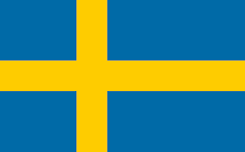 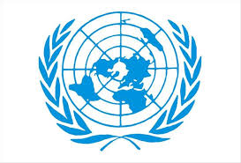

**Committee: UN WOMEN and Education**

**Delegate: Mehmet Emin Çelik**

**Country: Sweden**

**Topic: Addressing Barriers to Girls’ Education and Promoting Women’s Empowerment through Learning**  
**Overview of Sweden:**

**Sweden is a country located in Northern Europe, on the Scandinavian Peninsula. It is known for its mountains, cities, and high quality of life. Sweden became an independent kingdom in the 16th century and has followed a policy of neutrality in modern conflicts. The capital city of Sweden is Stockholm. The country is a constitutional monarchy governed by democratic laws. Most Swedes belong to the Evangelical Lutheran Church, but there is widespread religious freedom and diversity in the country.**

**The Vision and Suggestions of Sweden on Addressing Barriers to Girls’ Education and Promoting Women’s Empowerment through Learning:**

**Sweden places great importance on ensuring equal access to education for everyone, regardless of gender. Known for its strong commitment to human rights, gender equality, and social welfare, Sweden considers girls’ education and the empowerment of women essential for achieving global peace.**

**Sweden has long been practicing gender equality and promoting access to education, and is internationally recognized for these efforts. Within the borders of Sweden, the government has enacted laws that provide free education to its citizens, free from gender, socio-economic, or other forms of discrimination. The country regularly ranks as one of the world leaders in gender equality and access to education.**

**At the international level, Sweden is a strong supporter of UNESCO, UN Women, and the Global Partnership for Education, among others. It provides substantial funding to programs that aim to remove barriers to girls’ education, particularly in conflict zones and struggling regions. In addition, the Swedish government regularly calls for the protection of girls from early marriage, gender-based violence, and discrimination within education systems.**

**Sweden has called upon all countries to take collective action in order to remove both structural and cultural barriers that prevent women and girls from accessing quality education. In this regard, Sweden suggests that educational programs be designed to be inclusive and sensitive to local cultural contexts, while remaining in full compliance with universal human rights. Furthermore, Sweden advocates for increased investment in digital education technologies, particularly in rural and conflict-affected areas, to ensure that all girls can continue their education without interruption. Additionally, Sweden supports the strengthening of legal frameworks worldwide to eliminate child marriage and gender-based discrimination within educational systems. As a strong supporter of multilateral cooperation, Sweden extends its hand to all Member States in building a world where every girl has the opportunity to learn, lead, and thrive.**