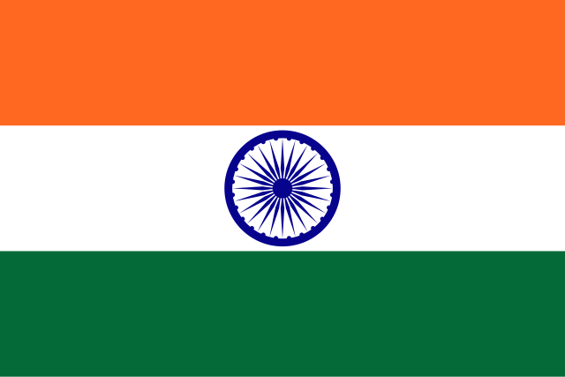

POSITION PAPER

Country: India

Committee: GA4: SPECPOL

Agenda Item: Neocolonialism in the 21st Century in the West African Region

The Republic of India is located in the region of South Asia. It is the seventh largest country in terms of size and the most populous country since 2023. Its coastline measures 7517 km with the Indian Ocean to its South, the Arabian Sea to its West and the Bay of Bengal to its East. Pakistan to its West, China, Nepal and Bhutan to its Northeast and Bangladesh and Myanmar to its East.

India’s population is totally 1,470,086,581

Neo-colonialism can be defined as the covert expansion of socio-economic and political activities of former colonial rulers aimed at strengthening capitalism, neo-liberal globalization and the cultural subjugation of their former colonies. In a neo-colonial state, the former colonial masters ensure that the newly independent colonies remain dependent on them for economic and political direction. The dependence and exploitation of the socio-economic and political life of the now independent colonies is carried out for the economic, political, ideological, cultural and military interests of the parent states of the colonial masters. This is usually achieved through indirect control of the economic and political practices of the newly independent states rather than through direct military control as in the colonial period.

From the late nineteenth century to the second half of the twentieth century, several European countries, such as France, Portugal, Britain and Belgium, colonized numerous African countries by establishing economic systems that apparently permitted extensive exploitation.

In the decades after World War II. European countries granted political independence to their African colonies, but still found new ways to maintain their economic influence and power over the former colonies. From 1950s onwards, when many African colonies began to gain independence, they soon realised that the real liberation they had been waiting for was strange. Despite the assumption that Africans were in positions of political leadership, Africans soon realised that the economic and political atmosphere was still under some form of control from the former colonizers. As a result, post-colonial Africa continued to experience the dominance of the Western-style economic model that was prevalent during the colonial era.

The neo-colonialism of today represents imperialism in its final and perhaps its most dangerous stage. In the past, it was possible to convert a country into a neo-colonial territory. Today, this process is no longer feasible. Old-fashioned colonialism didn’t completely finished. It is still an African problem, but it is on everywhere to retreat. Once a territory has nominally become independent, it is no longer possible, as it was in the last century, to reverse the process. Existing colonies may linger on, but no new colonies will be created. In place of colonialism as the main tool of imperialism, we now have neo-colonialism.

The essence of neo-colonialism is that the State in question is in theory, free and has all the outward trappings of international sovereignty. In reality, its economic system its political policy is directed from outside. The methods and form of this direction can take various shapes. For example, in an extreme case the troops of the imperial power may garrison the territory of a neo-colonial State and control the government of it. However, neo-colonialist control is exercised through economic or monetary means. The neo-colonial state may be obliged to take manufactured products of the imperialist power to the exclusion of competing products from elsewhere.

In the 21st century, great powers that needed the continent's resources and states that claimed to be regional powers came to the agenda with African initiatives. In addition to countries surrounding the continent with a modern exploitation system, especially the USA, Russia and China, India, which has a long and common colonial past with Africa, has also started to increase its visibility in Africa, especially after the 2000s. One of the most important reasons for the development of India-Africa relations is undoubtedly that both sides have come together on common ground. Although relations that started with commercial purposes via the Indian Ocean before colonialism stagnated when England became the dominant state in both regions, Africa became a base for the British during the process of transferring wealth from India to the United Kingdom. However, with India gaining independence in 1947 and the beginning of the independence struggle of African countries, relations evolved into another dimension. After gaining independence, the cornerstone of India’s Africa policy was to support the fight against colonialism and racism in Africa. India began to be visible in many parts of Africa with the African mobilization launched in the mid-1990s after the economic crises following the Cold War were overcome. Moreover, political and economic relations are being developed by the India-Africa summits, which were launched in 2008 and have been replicated every three years, most recently in 2015. Besides, the bilateral high-level visits that have occurred in recent years reveal that the India-Africa relationship has advanced considerably on the economic front. Specifically, under policies and initiatives such as "Focus Africa" launched in 2002 and later "Expanded Horizons" and "Team 9" programs, it embarked on reinforcing relations with numerous African countries. In addition, efforts are being made to establish political and economic relationships with the India-Africa summits, which commenced in 2008 and occur every three years, the latest of which took place in 2015. In addition, bilateral high-level visits in recent years have been an indicator that India-Africa relations have come a long way in the economic realm. India is the second largest lender in Africa with strong partnerships. India’s total investments in Africa amount to $70 billion, a figure the powerful Confederation of Indian Industry aims to increase to $150 billion by 2030. Since independence, India believed it was destined to be a Great Power, meaning a self-reliant and economically and militarily powerful India with global respect and influence. These ambitions remain anchored in Africa. India won independence from Britain in 1947 and was active in Africa’s independence movements. Besides Mahatma Gandhi, its early leaders (and prime ministers) Jawaharlal Nehru, his successor and daughter, Indira Gandhi, and grandson, Rajiv Gandhi, received dozens of decorations across Africa for their work on African liberation. Africa retains support across the political spectrum in India today.

As a country that has overcome itself from colonial legacy, India believes that efforts at combating neocolonial tendencies in West Africa must be Africa-led, development-oriented and broad-based.

Firstly, India is adamant about establishing financial frameworks owned by Africans that reduce reliance on conditionality-tainted foreign loans. Such frameworks should be complemented by multilateral coordination under the ECOSOC and the African Union umbrella.

Second, India encourages more South-South cooperation, especially in digital infrastructure, public health, and sustainable agriculture. India keeps pressing for increased technology transfer, vocational training, and educational partnerships through mechanisms like the Pan-African e-Network.

Third, India espouses that open global monitoring systems be created to study foreign investment and trade agreements on the continent so that they serve African development priorities and not external geopolitics.

Lastly, India calls for a re-thinking of existing trade agreements that institutionalize inequality and promotes open-ended negotiations that grant African nations more say in framing economic terms.

India is set to collaborate with African partners and the United Nations towards building a fairer world order one that respects sovereignty, fosters equity, and pursues shared prosperity.

Bibliography;

<https://iep-utm-edu.translate.goog/neocolon/?_x_tr_sl=en&_x_tr_tl=tr&_x_tr_hl=tr&_x_tr_pto=tc>

<https://en.wikipedia.org/wiki/India>

<https://www.worldometers.info/world-population/india-population/>

<https://countrymeters.info/en/India>

<https://oldmis.kp.ac.rw/admin/admin_panel/kp_lms/files/digital/Core%20Books/History/Neo-colonialism-in-west-africa.pdf>

<https://www.marxists.org/subject/africa/nkrumah/neo-colonialism/neo-colonialism.pdf>

<https://afam.org.tr/hindistanin-afrika-politikasi-idealist-dis-politikadan-gercekci-politikaya-ve-pragmatizme/>

[https://africacenter.org/spotlight/africa-india-cooperation-benchmark-partnership/?utm_](https://africacenter.org/spotlight/africa-india-cooperation-benchmark-partnership/?utm_source=chatgpt.com)