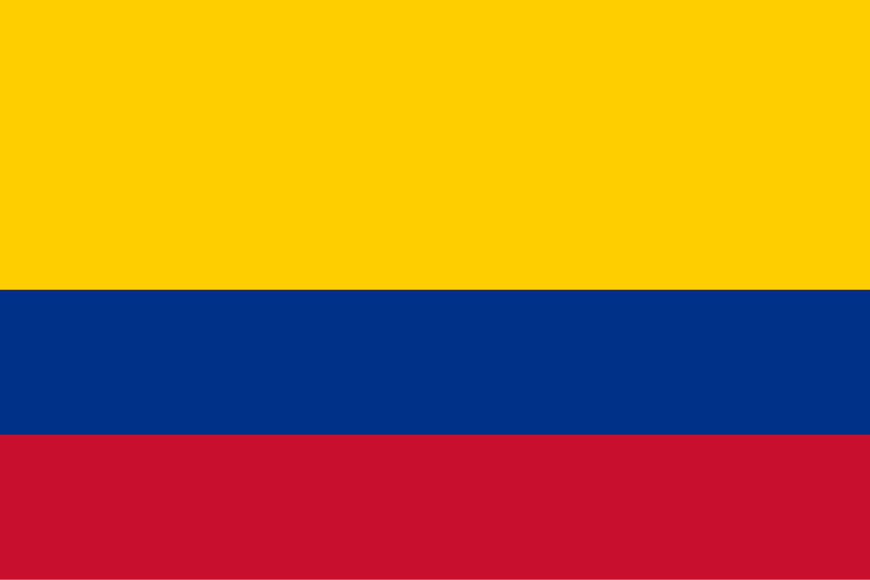Committee:SOCHUM

Country:Colombia

Agenda Item:Accomplishing Freedom of Press and Protection of Journalists

Within Conflict Zones

School:Ankabilim College

Delegate:Saner Karateke

Honorable Chair and Dear Delegates

The Republic of Colombia acknowledges how important journalists are to spreading the truth, especially during times of war. With a long history of internal violence, Colombia has seen directly the threats journalists face. Often from illegal armed groups and drug cartels. We fully understand how important it is to protect journalists rights and make sure they’re safe.

We as Colombia believe that journalists have rights to express themselves and should be protected by all governments and armed forces. We support stronger international cooperation to provide education about safety, digital safety, and emergency assistance to journalists working in high risk areas. We also call for stronger punishments for crimes committed against journalists under international law.

Even though we as Colombia have taken steps to improve journalists protections, more effort is needed both nationally and globally. Colombia supports international agreements such as the Universal Declaration of Human Rights and the Geneva Conventions to guarantee that journalists are treated as civilians and respected accordingly.

We are ready to work with other countries to guarantee that journalists around the world can report without any concerns and fear.

Colombia is ready to work with other nations to ensure that journalists around the world can report freely and without any fear.

BIBLIOGRAPHY

<https://rsf.org/en>

<https://www.un.org/en/safety-journalists>

<https://rsf.org/en/country/colombia>