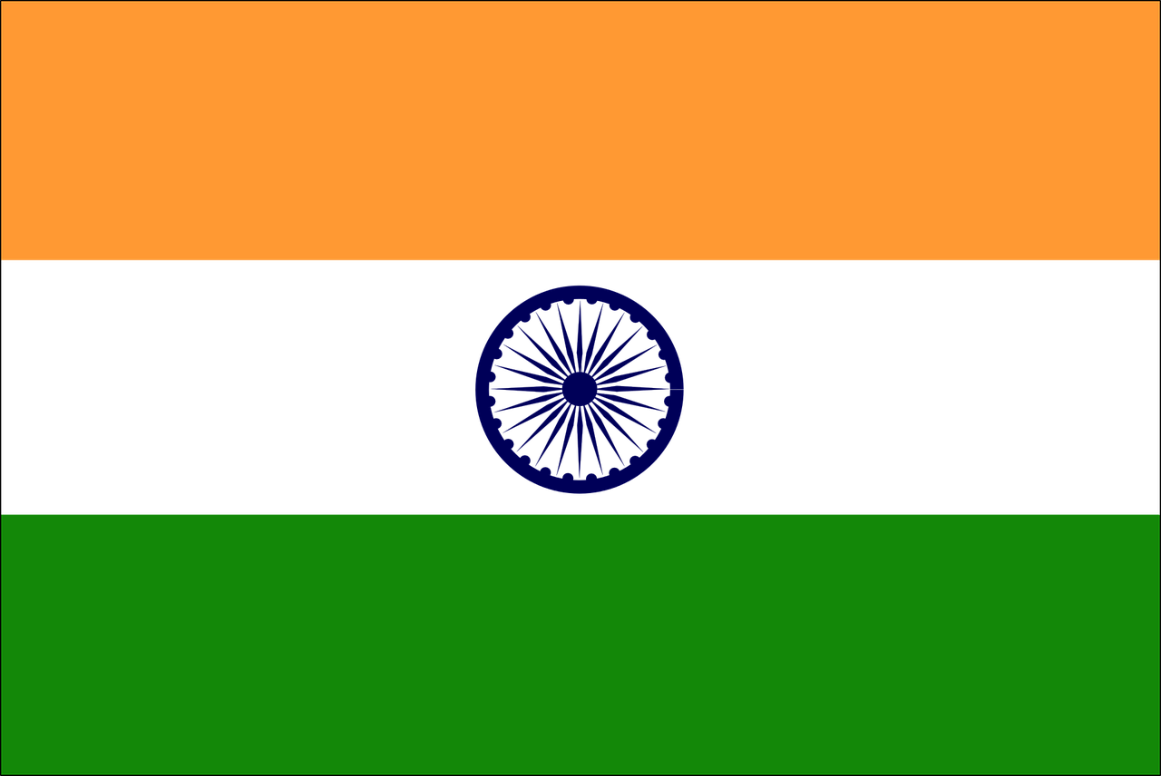

Committee: (ECOSOC)

Agenda Item: Promoting Gender Equality and Empowering Women in Developing Economies

Country: Republic of India

The Republic of India is located in South Asia, and it shares borders with the countries Pakistan, China, Nepal, Bhutan, Bangladesh, and Myanmar. With a population that surpasses 1.4 billion, India has the fifth largest economy globally, with a GDP of nearly $3.7 trillion. India is committed to promoting the principles of equality and social justice and actively creates policies aimed at promoting gender equality and empowering women, particularly in developing and growing regions. India highly values equality and the safety of their citizens, and wants to strengthen their policies in order to achieve such things.

In the past decades, India has faced difficulty in areas of gender inequality and discrimination against women. To address these issues that have arisen, India has worked hard to implement a range of policies that address gender inequality and enhance women’s empowerment in many sectors in the last few decades. One of those many policies, The Beti Bachao Beti Padhao (Save the Daughter, Educate the Daughter) campaign, focuses on improving the wellness and life quality of girls, particularly in regions with low female literacy and unequal birth ratios. Another policy, The Stand-Up India scheme, loans bank loans for women entrepreneurs, which promotes financial independence for women in such industries. Additionally, the Sexual Harassment of Women at Workplace (Prevention, Prohibition and Redressal) Act, pursued in 2013, provides a legal stepping stone to protect women from workplace harassment, ensuring a much safer work environment for them.

India recognizes the importance of education in empowering women and has established the Gender Inclusion Fund under the National Education Policy in 2020 to support girls and students in accessing their deserved education by providing free additional educational resources to girls, financial assistance for female students and teachers in need, and implementing teacher sensitization programs to promote gender-inclusive teaching practices. The recent passage of the Women’s Reservation Bill, established in 2023, reserving a third of the seats in the Lok Sabha and state assemblies for women, shows significant evolution and a massive step towards increasing women’s political representation in the country. Furthermore, the Subhadra Yojana offers financial help to women from economically weaker sections, promoting economic empowerment through directly benefitting their transfers.

As India, we advocate for many collaborative efforts among other developing economies such as ourselves to teach practices and share resources in promoting gender equality. As we believe that collaboration is our best chance at growing together, we propose the establishment of a South-South cooperation that can focus on women’s empowerment surrounding areas of education, healthcare, and economic participation together. We are interested in working with international partners in order to develop intellectual strategies that address the root of the challenges faced by women in developing economies, ensuring sustainable and ever-growing development.

Bibliography:

• Ministry of Women and Child Development, Government of India. “Beti Bachao Beti Padhao Scheme.” https://wcd.nic.in/bbbp-scheme

• Stand-Up India Scheme. https://www.standupmitra.in

• Ministry of Education, Government of India. “National Education Policy 2020: Gender Inclusion Fund. ” https://www.education.gov.in/national-education-policy-2020-provides-setting-gender-inclusion-fund-gif-especially-girls-and

• Parliament of India. “The Sexual Harassment of Women at Workplace (Prevention, Prohibition and Redressal) Act, 2013.” http://wcd.nic.in/sites/default/files/Sexual-Harassment-at-Workplace-Act.pdf

• Press Information Bureau, Government of India. “Subhadra Yojana.” https://pib.gov.in/PressReleasePage.aspx?PRID=1744287

   
 