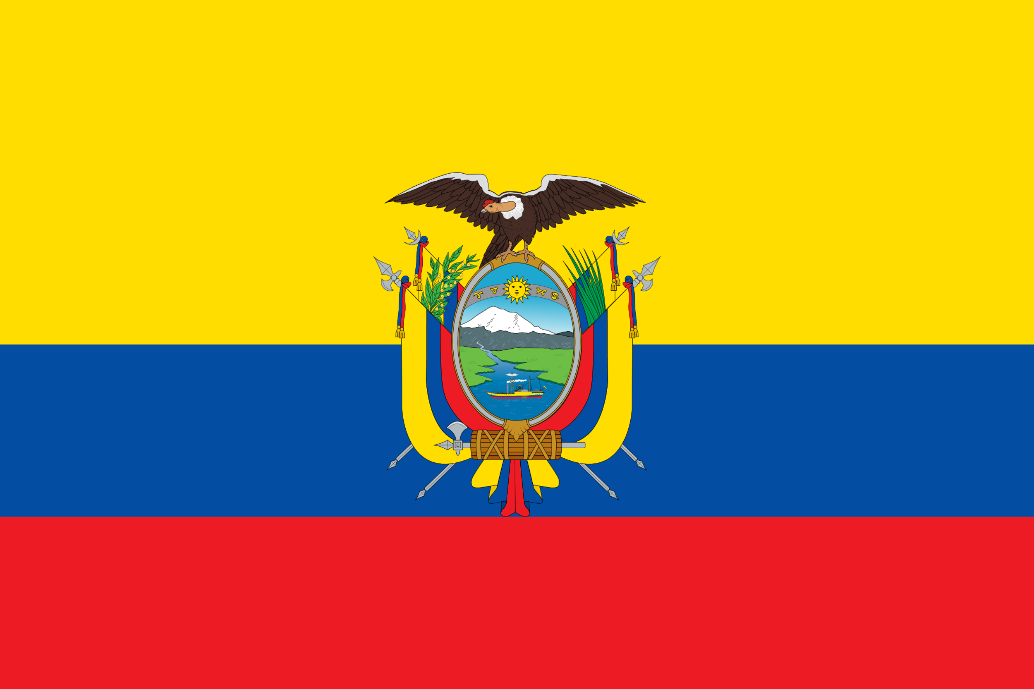**Country**: Republic of Ecuador

**Committe:** SOCHUM

**Agenda** **Item**: Press Freedom For Journalists

Ecuador, officially the Republic of Ecuador, is a country in Northwestern South America, bordered by Colombia on the north, Peru on the east and south, and the Pacific Ocean on the west. It also includes the Galapagos Islands in the Pacific, about 1,000 kilometers (621 mi) west of the mainland.

The country's capital is Quito and its largest city is Guayaquil. Spanish is the official language spoken by a majority of the population, although 13 native languages are also recognized, including Quechua and Shuar. Ecuador is a representative democratic presidential republic and a developing country whose economy is highly dependent on exports of commodities, primarily petroleum and agricultural products.

**Agenda** **Item**: Press Freedom For Journalists

There is no widespread blocking or filtering of websites in Ecuador and access to blogs and social media platforms such as Facebook, Twitter and YouTube is generally free and open. Various national and international sources of information can be accessed via the Internet. Therefore, news written in the newspaper is also easily accessible to the public through social media and the internet. However, where journalists go to exercise their right to freedom of the press, they sometimes face threats, assassination, kidnapping and torture.

There are some things that can be done such as:

* Where journalists' right to freedom of the press is restricted, they can be fined and, if the situation is more serious, imprisoned.
* A special law should be passed for journalists and members of the press and they should be issued a press card so that they can enjoy freedom of the press.
* For their economic freedom, the labor law could be amended to include some additional measures.
* Special service passports can be issued to members of the press.
* Police protection should be allocated for those in life-threatening situations.
* Journalists' vehicles can be assigned special license plates.