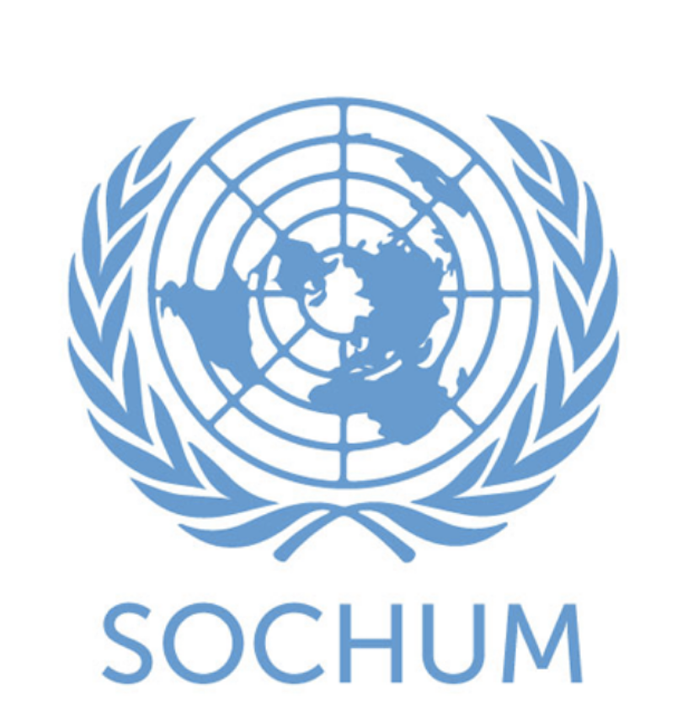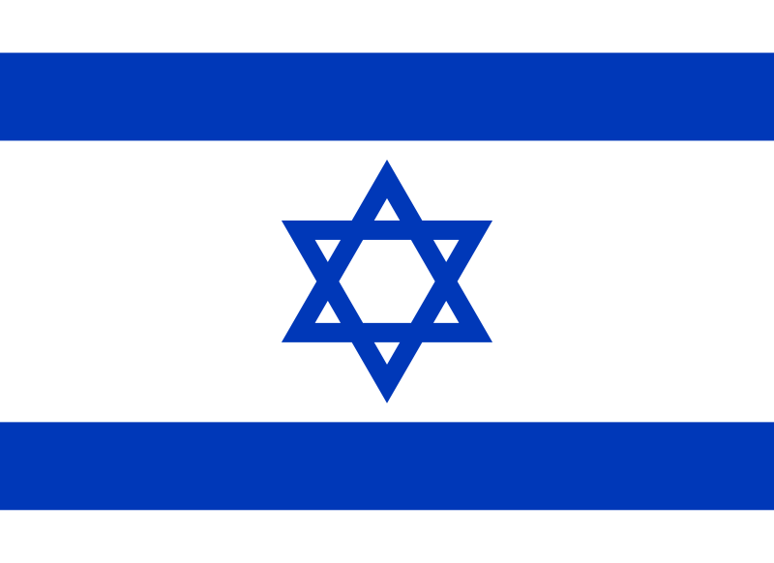

**Committee**: Social, Humanitarian and Cultural Committee (SOCHUM)

**Agenda**: Accomplishing Freedom of Press and Protection of Journalists Within Conflict Zones

**Country**: State of Israel

**Delegate**: Yağız Kaan Uzun

The State of Israel recognizes the importance of journalists in providing transparency. As a democratic country with one of the most active press landscapes in the Middle East, Israel values the right to freedom of expression and the press. However, Israel also faces some major security threats. In conflict zones ensuring both the safety of journalists and the security of Israeli civilians becomes a hard challenge. Israel thinks that while media freedom is crucial, it must be balanced with the need to prevent the misusage of press privileges for incitement or the spread of misinformation during armed conflict.

In areas of active conflict, including Gaza and the West Bank, restrictions may be placed temporarily on journalistic activity to prevent sensitive information from being leaked by hostile groups. Israel does not support any form of willful harm to journalists and condemns the targeted attacks which are against the media personnel by state or non-state actors. At the same time, Israel has experienced some situations over and over again where media platforms have been used to spread incitement or to serve for terrorist organizations. In such cases, a detailed approach is a necessary one that respects journalistic freedom while upholding national security.

Israel believes that this committee must focus on taking actions and more realistic solutions that recognize both the importance of press freedom and the challenges within conflict zones. One recommendation is the development of an international Journalist Recognition Protocol under the name of the United Nations. This would help distinguish legit journalists from individuals who may exploit media roles to support hostile actors, and it would ensure better protection for verified reporters.

Israel is prepared to take part in this committee to craft a resolution that safeguards journalists while recognizing the very real challenges faced in conflict zones. The goal should be to protect those who report the truth and not those who manipulate it for violence.

**Bibliography**

<https://rsf.org/en/country/israel>

<https://cpj.org/mideast/israel/>

<https://www.ohchr.org/sites/default/files/2023-11/briefer-impact-counter-terrorism-criminal-laws-media-fredom.pdf>

TedMUN Study Guide