Committee: UN WOMEN
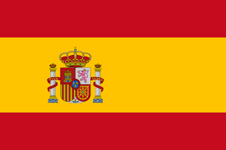
Country: Spain
Agenda item(s): Women’s Access to Justice and Legal Protection
It is a matter of the fact that most of the women around the world cannot access to justice and legal protection. There are still 49 countries that have no law to protect women from physical or sexual violence. Moreover, women can’t even use their rights in most of the countries that have laws. Women’s access to participate in politics, and wage gap between genders are global problems and need to be improved as soon as possible. Discrimination based on the gender is one of the biggest issues that exist.
If we attempt to draw a parallel between this discrimination and the reason of it, we would say that cultural background and lack of education. Despite the progress we have made in descreasing the gender discrimination, approximately 90% of countries have laws that discriminate against women. Unfortunately, 19 countries entitled men to force their wives to obey them. Only in 91 countries, laws or customary practices enable women to have equal rights. There are almost 35% of women exposed to sexual or physical violence. We can extend the number of examples.
Gender equality policies in Spain have shown a path of positive development from the 1980s. And it is still in the progress. Laws that would revolutionize civil law by giving women great freedom have been approved by the Cabinet.
That would be easier if goverments ensure gender equality in law even though the society thinks or says the otherwise.

