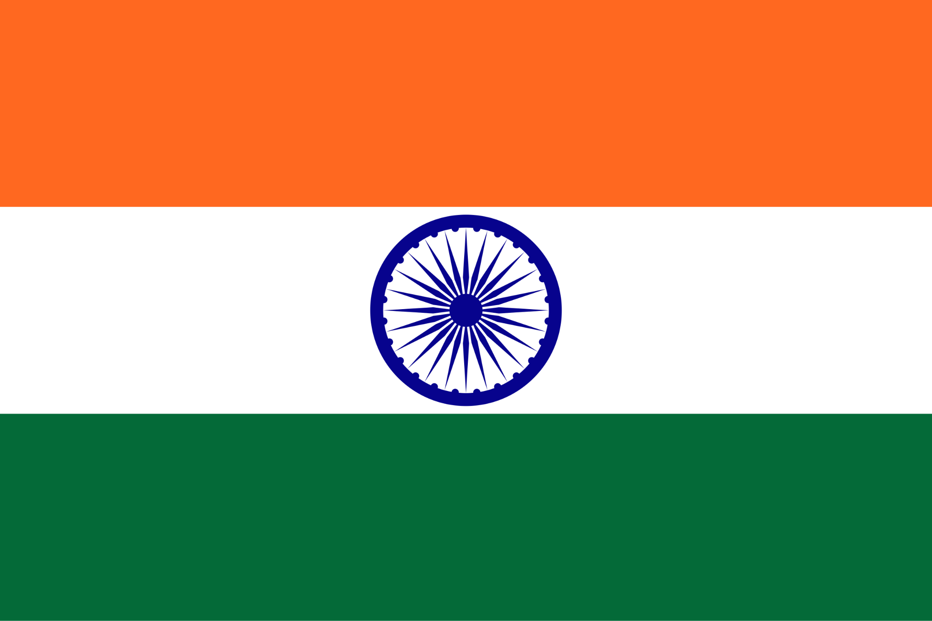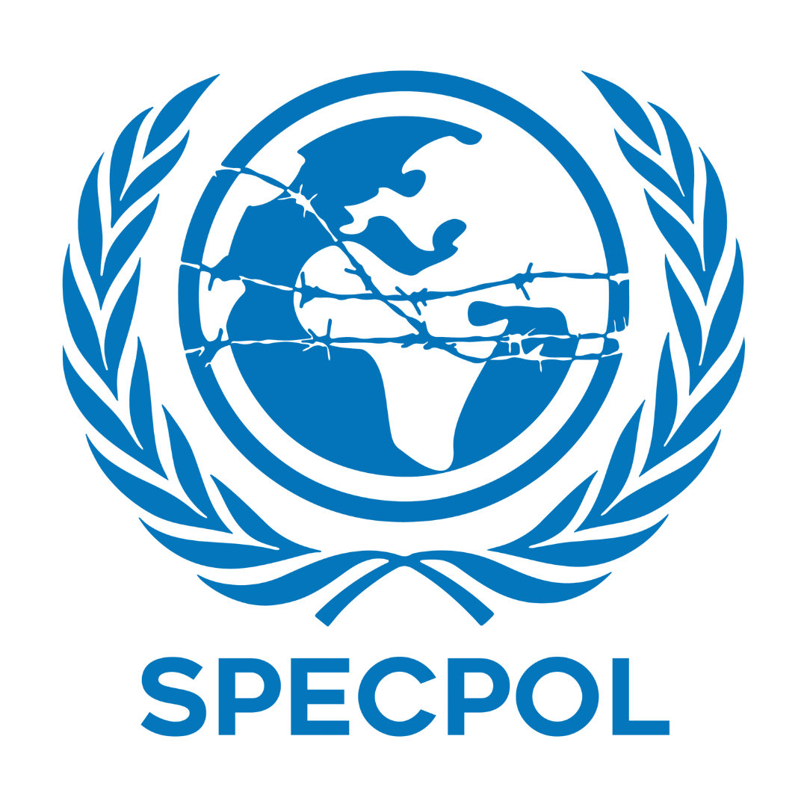**Country**: India

**Committee**: SPECPOL

**Agenda Item**: Governmental Stabilization

after the Bangladesh Political Crisis

**Delegate Name**: Süheyla Torbacı

The United Nations General Assembly Fourth Committee (also known as the Special Political and Decolonization Committee or SPECPOL or C4) is one of six main committees of the United Nations General Assembly. It deals with a diverse set of political issues, including UN peacekeeping and peaceful uses of outer space.

The political crisis in Bangladesh, which escalated recently and was caused by significant social and political instability, has lasting effects on both Bangladesh and its neighbors, especially India.

India sees this crisis as a threat not only to the democratic structure of Bangladesh, but also to the security, trade, and cooperation across South Asia. A stable and democratic Bangladesh is crucial for ensuring peace along our shared border, supporting regional development, and maintaining strong diplomatic ties.

India is deeply concerned about this crisis because of several reasons. Some of them are that India and Bangladesh share one of the longest frontiers of the world, they’re close neighbors and any possible outbreak of some civil war or destabilization in Bangladesh, India may face waves of mass migration. Also the chaotic atmosphere in Bangladesh can build a suitable ground for some extremist groups or radical communities to plan further operations. India is also worried that the crisis could damage the long-standing friendship and trust between the two nations, as such instability could also harm trade and economic cooperation between the two countries.

India has always maintained a strong and supportive relationship with Bangladesh, since the 1971 Liberation War. Starting from then, India has always supported Bangladesh and still continues to work closely with it for regional peace and development.There are so many projects which are made by India to help Bangladesh to grow and stabilize.

India solidly believs that stabilization in Bangladesh must begin with inclusive national dialogue. All the political figures, including opposition parties, civil society organizations and youth representatives, should be given the space to participate in shaping the country’s future.

Republic of India remains committed to supporting Bangladesh during this critical time. We believe that, together with the international community, we can help create a stable, democratic, and prosperous future for the people of Bangladesh. A stronger Bangladesh means a stronger region and that’s something we all benefit from.

**Bibliography**

<https://www.mea.gov.in/Portal/ForeignRelation/Bilateral-Brief-Bangladesh-February-2024.pdf>

<https://www.orfonline.org/expert-speak/the-fate-of-india-bangladesh-connectivity-projects>

<https://thedocs.worldbank.org/en/doc/f6dd176b982714b6e3b04d7ac672a0ab-0310012024/original/Bangladesh-Development-Update-April-2024-w-cover.pdf>

<https://www.undp.org/bangladesh/publications/country-programme-document-bangladesh-2022-2026>

<https://www.orfonline.org/expert-speak/the-fate-of-india-bangladesh-connectivity-projects>