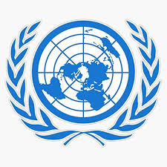
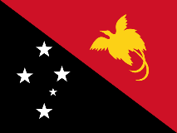
ENSURİNG THE RİGHTS OF INDIGENOUS PEOPLES İNTHE CONTEXT
OF CLIMATE CHANGE AND ENVİRONMENTAL DEGRADATİON
Country: Papua New Guinea
Committee: SOCHUM
Delagate: Beril Nur Saymalı

Papua New Guinea has historically been a home to indigenous peoples of many different ethnic origins. Hundreds of ethnic groups are indigenous to Papua New Guinea. Most of these are known as Papuans, while others are known as Austronesians. Papuans are found in the southern and inland regions of the country. Melanesians are in the north and east, and Pygmies in the west. Our country ranks first in the world in terms of linguistic diversity, with over 850 indigenous languages. ( https://tr.wikipedia.org/wiki/Papua_Yeni_Gine) This means our country holds a significant place in the world in terms of ethnic diversity, biodiversity, and linguistic diversity. Papua New Guinea believes the Article 25 of the UNDRIP (The United Nations Declaration on the Rights of Indigenous People) which is about climate change is a violation —rights to land, territories, and resources. It also believes it is causing the loss of cultural identity.

Although Papua New Guinea has contributed least to the climate crisis, it is currently one of the most affected country. This situation can be explained by its status as a developing island, its low-lying coastal areas, its location on the Pacific Ring of Fire, where tectonic movements are intense, its numerous tribal and inter-tribal conflicts, and its poor economic conditions. The majority of our population lives on coral islands, and these islands are low-lying. This shows that we are under threat from rising sea levels. The Carteret Islands incident we are experiencing is an example of this situation. Our people were forced to migrate because of that incident. (Certarets Integrated Relocation Programme 2007) Because our country is located on the Pacific Ring of Fire, it experiences devastating landslides. When our resources decrease for these disasters, conflicts between tribes occur.

In light of these situations we demand the full activation of the Loss and Damage Fund. We demand the mandatory implementation of the FPIC principle to ensure the legal protection of the rights of our indigenous people. Furthermore, the forced displacement of our indigenous people and their displacement from their inherited lands is a violation of UNDRIP 25. To prevent this violation, we demand legal reform of UNDRIP 25 and UNDRIP Articles 3.

