Committee: The Special, Political and Decolonization Committee (SPECPOL)   
  
Country: Spain  
  
Agenda: Governmental Stabilization after the Bangladesh Political Crisis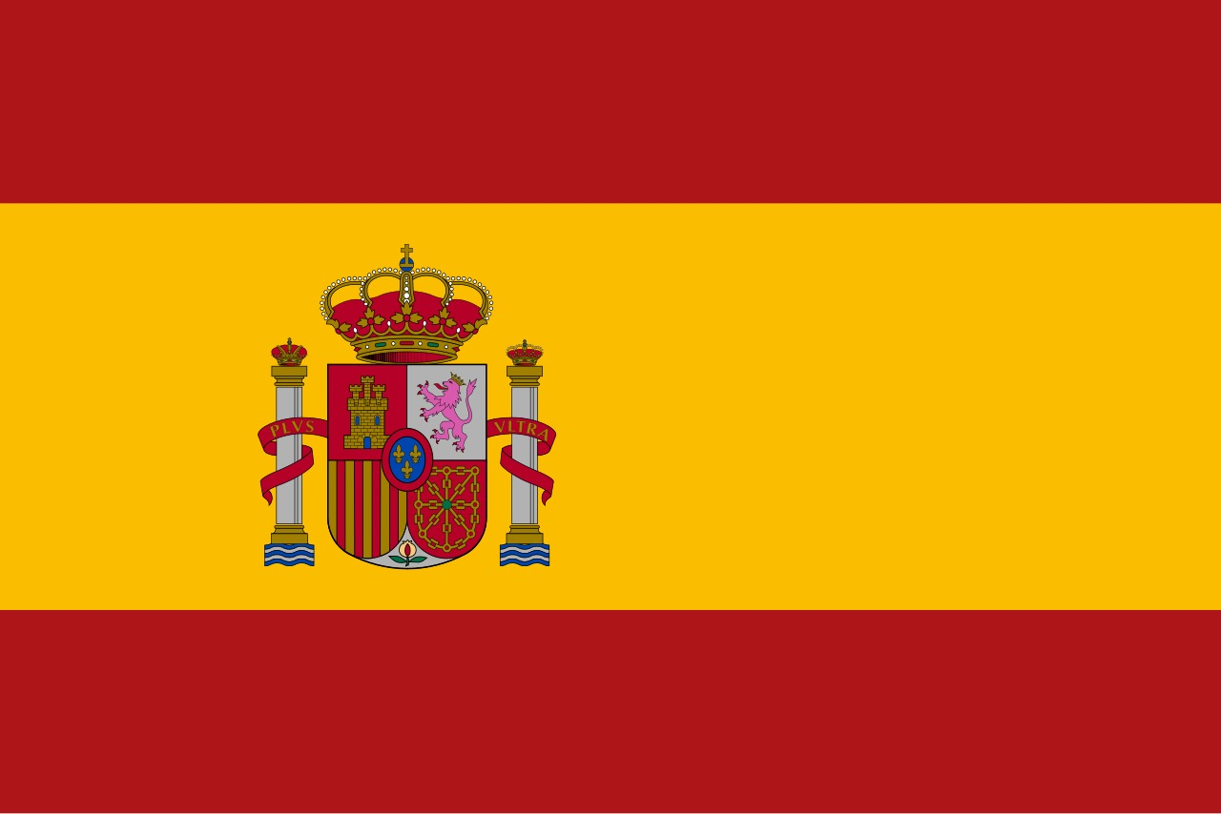  
  
Delegate: Arda Ata Caba  
  
  
  
The Kingdom of Spain recognises that there is a need for stabilisation of the Bangladesh government in the long term in view of recent multi-dimensional crises. The Spanish view is that political, economic, and social reforms need to be coupled with full restoration of values such as democracy as well as humanitarian protection to bring about peace and development in the area.

The Bangladesh crisis of 2022-2024 brought with it an apocalyptic governance breakdown in the shape of political terrorism, electoral strife, widespread unemployment, censorship over human rights, and hyperinflation. The resignation of Prime Minister Sheikh Hasina and swearing in of Nobel laureate Muhammed Yunus as Chief of a caretaker government is an opportunity window to rebuilddemocracy. The pledges by the caretaker government to bring about reforms in society, freedom in media, and economic resurgence are appreciated by Spain.

Being part of the European Union as well as being an advocate of international collaboration and human rights, Spain is in agreement with United Nations, European Union, and other international community initiatives to help Bangladesh undergo transition. Spain believes international monitors are needed for elections in 2026 to ensure transparency as well as credibility.

Spain is in favour of Election Commission reform to bring an end to partisanship to clear the way for public trust in elections to be restored. Additionally, we insist that freedom of expression, with an independent media, are non-negotiable values in an orderly political system. Media organizations, as well as journalists, need to be free from censorship, and fresh online laws need to keep in accordance with international privacy norms as well as civil liberties. Economically, Spain supports Bangladesh's government in stabilizing the prices, consolidating monetary policy, and generating employment opportunities through initiatives such as Employment Generation Program for the Poorest (EGPP). Spain also aims at Small and Medium Enterprises (SMEs) since they are promoters of inclusive economic growth.

On humanitarian grounds, we acknowledge that Bangladesh is under immense pressure due to the ongoing Rohingya refugee issue. We appeal to the international community to continue donating more money to humanitarian aid so that rights are protected and dignity is maintained for the refugees.

In brief, Spain remains committed to supporting a peaceful, democratic, and inclusive transition in Bangladesh. We remain ready to work in partnership with other countries in promoting lasting political and economic change, ensuring human rights are respected, and promoting long-term regional stability.