Position Paper

Flag:

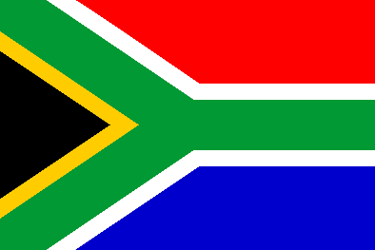

Committee: SOCHUM

Agenda Item: Ensuring Equality

Of Opportunity On Children’s Access To Education

Country: South Africa

Delegate: Nefes Şahin

School: Liv College

South Africa is one of the largest countries in the world. The president is Cyril Ramaphosa and the currency that is used is Rand. The people of South Africa from different religions live together which happen to be %86 Christian, %2 Muslim and the rest believe in the indigenous religions of South Africa. The citizens of the country can vote when they reach the age of 18. Nevertheless, there are some big issues regarding the goverment of South Africa such as young children not being able to get a good education and most of them having to work under poor conditions.

Education is the biggest right of all children. A country without education is a country without a future. It is a very crucial right as much as food, shelter and live. A developed country needs well educated young people. We must raise young generation with developed imagination in order to look the future with hope. Young people need an education system that opens horizons so they can dream.

As South Africa; we give a great importance to education. In general, the rate of people who are able to read and write is over 90%. Although great importance is given to education, the quality of education varies depending on the region where children live. The quality of education for children living in poor and arid regions is very low, for instance some of the classrooms do not even have desks, or they do not have any technology.Not only this,these areas also face to transportation problems due to long and unconstructed roads.

The education system in South Africa still bears the traces of apartheid. This system is divided into two. While the rich have the opportunity to get a good education, the poor, especially the citiszens who live in rural areas, do not have the same change. The education sytstem is full of difficulties, many students can not even graduate from high school therefore their university dreams unfortunately fail. Only 15% of students in the country can enroll in universties; however, only 30% of them can graduate.

As South Africa the administration needs to increase the budget allocated to education, reduce security and administrative expenses, and add this money to the budget for education. Equality of opportunity in education should be ensured by increasing the education budget. For this, children's access to education must be improved, their access to school must be enhanced and their nutrition must be ensured, because children are the future of this world, and they are the ones who need to be taken care of.