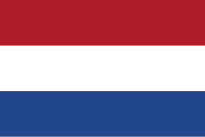Counrty:Netherlands

Committee:UNWOMEN

Topic:Addressing Femicide Through Legislative Action and International Cooperation

Netherlands is a country lacated in Northwest Europe neigbouring the countries of Belguim and Germany.Amsterdam being the biggest city in Netherlands is also the capital of the country. Netherlands covers an area 41.865 km square and has an estimated population containig 17 million citizens.

Netherlands has established potent effective legal measures to combat against both physical and mental abuse against women,including femicide.Domestic violence, stalking and gender based killing are punishable under Dutch criminal law.The goverment has developed a program named “Violence Does Not Belong Anywhere” program whic focused on prevention early intervention and long-term fınancıal and mental support for victims.Netherland provides educatioanal initiatives and awareness capaings that adresses the importance of equality between genders.

İn Netherlands we think that standerdized data collection systems sgould be created to track femicide cases and identify patterns and we are working towards the idea.

Netherlands stands ready to cooperate with member states and UN bodies to ensure a coordinated and effective global rsponse to end femicide and protect the rights and lives of women all around the world.

Biblography

<https://en.wikipedia.org>

<https://www.britannica.com>