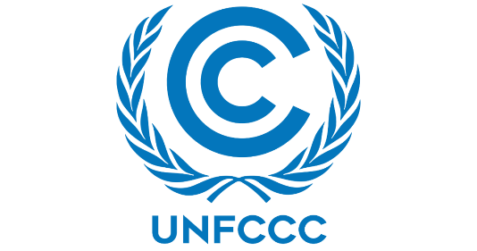 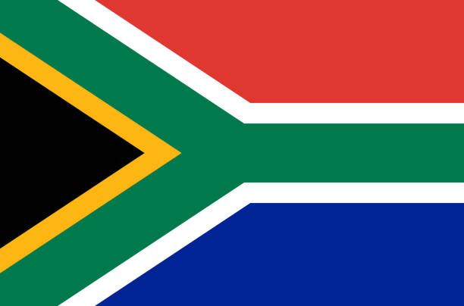

Country: South Africa

Committee: UNFCCC

Agenda Item: Increasing the usage of renewable energy in developing Countries

In the South of Africa we stand at 1,219,912 km2 our renewable energy sources are next to nothing however it does not mean we are not trying to get renewable sources although, we have wind, solar, hydroelectric and biomas as renewable energy sources and planing on doubling the usage by 2025.We get 2500 hours of sunlight thanks to our countries mass and its steppe flora making it easier for solar enegry to be collected.

We have done a National Energy Act in 2008 to support renewable sources to be use in our contry. We are using Renewable Energy Independent Power Producers Procurement Programme Since 2011 South Africa first introduced the REI4P. The program includes an initiative to install 17.8GW of renewable energy in South Africa before 2030.

So in our solution we can drive electric cars to gasoline cars, we can prefer public transformations. If we have factory, we need to use filters and we need to do maintain the filter. We need to reduce fossil fuel use. relied on fossil fuels for 83% of its electricity generation, and we need to decrease the fossil fuel rate. We need to use more solar panels for decreasing the fossil fuel rate. We can make the use of resources more depended on nature rather than fossils that will run out eventually

References: <https://dunyaenerji.org.tr/>,

<https://www.trade.gov/>,

<https://ticaret.gov.tr/>,

<https://en.wikipedia.org/>