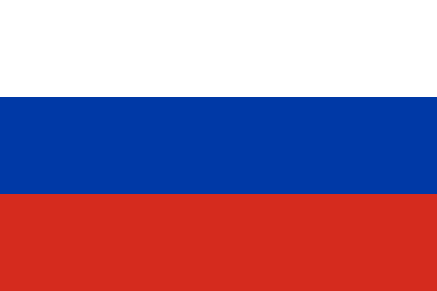**Committee:** UNSC (United Nations Security Council)

**Country:** Russian Federation

**Agenda Item:** The situation in the Central African Republic

The Central African Republic (CAR) is located in the centre of Africa. The territory has no land to sea.1 Before the CAR gained its independence in 1960, it was a French colony and was part of French Equatorial Africa.2 CAR has always had a lack of authority since the foundation of the country. This caused local people to gang up and this led to coups. In 2013, the fifth coup took place. A Muslim rebel coalition called ‘Seleka’ captured the capital of CAR, Bangui and forced the President François Bozize to flee.3 The new president was Michel Djotodia, who is a Seleka leader. Seleka’s abuses resulted with the foundation of a Christian rebel group called ‘Anti-Balaka’. This coalition also commits human rights abuses but mostly against the Muslim people. Since the breakout of the coup, thousands of people have been killed and over 750.000 people became refugees.4 François Hollande, who was the French President, called the United Nations (UN) about the situation and the UN has sent 3000 peacekeepers to the territory. Although the ban on Seleka, the Anti-Balaka revenge attacks were counterattacked by the ex-Seleka members.4 These actions led to the ethnic cleansing of the Muslim population in the capital and western CAR. After the resignation of President Djotodia in 2014, Catherine Samba-Panza was elected by the Transitional Council.1 In July 2014, a ceasefire was signed by the Anti-Balaka and Seleka rebel coalitions.1 Faustin-Archange Touadéra won the elections held in 2016.3 The territorial partition caused a pause to the fight of Muslims and Christians but the fights between the ex-Seleka groups increased. Even though the capital was under the control of the government, the attempts to calm the region with disarmament, the armed groups boycotted these trials. The government was out of control rather than the capital. The lack of laws and authority caused armed groups to improve and the fights were all among the central, eastern and western territories. These conflicts left nearly 75% of the population in poverty.4 In 2020, an election was held. Touadéra won the election.3 Three Burundian peacekeepers were killed and two were injured during the process leading up to the vote. During the election process he was supported by the Wagner Group and Rwandan troops.4 The United Nations Multidimensional Integrated Stabilization Mission in the Central African Republic (MINUSCA) was established in 2014. The main principles of the MINUSA are protecting civilians, supporting the authority of governments and states, implementing ceasefire and etc.6 In 2017, the Anti-Balaka rebel group attacked the Bangassou Massacare. MINUSCA managed to take control of the territory again. Four years later, Coalition of Patriots for Change (CPC) and the Popular Front for the Rebirth of Central African Republic (FPRC) tried to take control of the territory. But again MINUSCA managed to recapture the land.5

The Wagner Group is a private military company (PMC) in Russia. Since it is a private company, this group has no relationship with the government directly. The accusations of harassing civilians, committing abuses and consolidating Russian influence in the country have not been proven yet. The company is accused of untaxed rights to extract and export valuable natural resources, especially gold and diamonds, but these have not been proven.7 Under Article 359 of the 1996 Russian Criminal Code, PMCs are illegal. Article 359: “Recruitment, training, financing, or any other material provision of a mercenary, and also the use of him in an armed conflict or hostilities, shall be punishable by deprivation of liberty for a term of four to eight years.”8 This means that PMCs are not legally registered and they do not pay taxes to the state. So the Wagner Group is not officially recognised as a Russian company and does not officially exist.9

The Russian Federation is open to any kind of contribution upon ensuring the security of civilians and helping the Central African Republic to gain authority. Russia supports the idea of implementing the Disarmament, Demobilization, Reintegration (DDR) with the monitoring of the United Nations to ensure the act is done by an unbiased side. With the DDR the rebel groups will be disarmed and reintegrated to civilian life.

Russia is willing to a creation of a control mechanism on the trade of valuable natural resources, especially gold and diamonds. This mechanism should be under the control of the United Nations. This mechanism will secure the trades and ensure transparency. With this system corruption, illegal trade and fraud risks will be minimized.

The Federation of Russia recommend that, in a sudden coup the permanent members of United Nations Security Council, UNSC, (People’s Republic of China, French Republic, Russian Federation, United Kingdom of Great Britain and Northern Ireland, and United States of America) must send a military support aiming to protect the civilian population.

The Russian Federation encourages the permanent members of the UNSC to increase the military capacity of MINUSCA. This will help MINUSCA by spreading around more areas and providing civilians a better security. Also Russia believes that providing more quality equipment and more effective training will make peacekeepers more successful and help the implementation of peace more easily.

**REFERENCES**

1. O'Toole, T. E., Giles-Vernick, T. L., & van Hoogstraten, J. S. F. (2025, May 13). *Central African Republic*. Encyclopedia Britannica. <https://www.britannica.com/place/Central-African-Republic>
2. BBC News. (2023, August 22). *Central African Republic country profile - BBC News*. <https://www.bbc.com/news/world-africa-13150040>
3. Central Intelligence Agency. (2025, June 4). *Central African Republic - The World Factbook*. <https://www.cia.gov/the-world-factbook/countries/central-african-republic/>
4. Council on Foreign Relations, Center for Preventive Action. (2024, July 9). *Conflict in the Central African Republic | Global Conflict Tracker*. <https://www.cfr.org/global-conflict-tracker/conflict/violence-central-african-republic>
5. United Nations. (2017, May 13). *Armed group attacks civilians, UN in Central African Republic overnight; peacekeeper killed*. United Nations Peacekeeping. <https://peacekeeping.un.org/en/armed-group-attacks-civilians-un-central-african-republic-overnight-peacekeeper-killed>
6. United Nations. (2014, April 10). *About | MINUSCA*. UN United Nations Peacekeeping. <https://minusca.unmissions.org/en/about>
7. Sauer, P. (2022, August 7). *Russia's private military contractor Wagner comes out of the shadows in Ukraine war*. The Guardian. <https://www.theguardian.com/world/2022/aug/07/russias-private-military-contractor-wagner-comes-out-of-the-shadows-in-ukraine-war>
8. Butler, W. E. (Trans.). (1997). *Criminal Code of the Russian Federation*. Simmonds & Hill. <https://www.legal-tools.org/doc/8eed35/pdf/>
9. Doxsee, C. (2022, September 15). *Putin's Proxies: Examining Russia's Use of Private Military Companies*. Center for Strategic and International Studies. <https://www.csis.org/analysis/putins-proxies-examining-russias-use-private-military-companies>