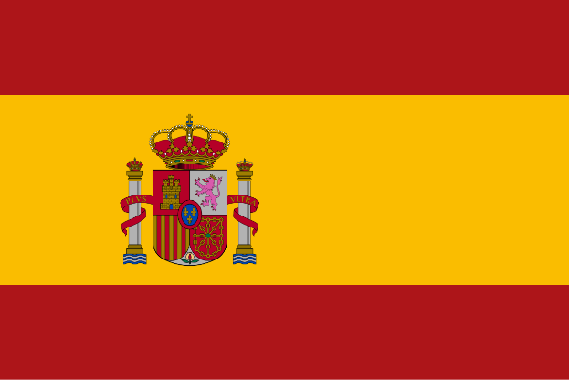Committee: North Atlantic Treaty Organisiation

Country: Kingdom of Spain

Agenda Item: Potential NATO Measures To Counter

The Growing Danger Posed by The Eastern Block

Conflict

Spain is a country located in Southeastern Europe we share land borders with France and Andorra with Portugal on the West. We additionally have a coast along the Mediterranean Sea and our country is bordered by the Atlantic Ocean. The current population f our country is 48,37 Million. Our policy is side with peace. We give importance to our poeple . We care about their rights. As a country with one of the strongest economies in the world our primary focus is a peaceful world. Our policy is side with peace and security. As the Kingdom of Spain we make it our business to provide people a more secure, humatarian and peaceful living space. The Kingdom of Spain is a strong and a massive country it borders a lot of countries also when a country is economically strong it leads to a lot immigrations therefore there are a lot people from different nationalities in our country. But this is not a new thing for us we learned how to live together and the reason we can do that is because we care about human and we care about their rights there are a few policies that we watch for human rights such as International Human Rights Advocacy, Freedom of Speech and Expression, Gender Equality and Women Rights etc. however what we do, there some countries in the world who demonstrates a lack of concern for human rights such as Russian Federation’s inhumane actions against Ukraine.

Currently there are tensions which has to be eased on the eastern block which adresses the tension that occured between the Russian Federation and Ukraine by the help of third party mediators and international agencies such the Secretary general of the UN (Antonio Guterres).

The problem appeared on Most importantly we would also like to talk about the current situation going on between Russia and Ukraine. On 24th February 2022 Russia attacked to Ukraine and started a conflict and this wasn’t something unexpected it was simmering since 2014 ,2022 was the breaking point of Russia. Russia didn’t have any concern about civilian deaths. According to the UN there were thousand of confirmed deaths of civilians. As we stated before Russia violated Human Rights, International Law, European Court of Human Rights (ECHR), The Budapest Memorandum, The Geneva Conventions and The United Nations Charter so we can get to the conclusion that Russia doesn’t even comply with international treaties. They attacked to 12 cities including the capital Kyiv they caused deaths of thousands of innocent people including women, children . Russia also attacked to hospitals , schools ,apartments in Kharkiv which is the second largest city in Ukraine. According to the International Law schools and hospitals should be protected in armed conflicts besides Geneva Conventions states that it is prohibited to attack to places such as hospitals and schools basically places which civilians need for their basic needs. In addition Russia has advantages over Ukraine which makes the conflict injustice and unfair and these advantages could be listed as military, supply chains ,logistics, technological developments and economy. We would like start with military advantages Russia has different branches of military including land, airforce and armor etc. their various branches of military provides them a more effective and a stronger coordination. Besides Russia owns one of the largest armies on the world so they have a numerical superiority over Ukraine. Also since Russia is economically superior too they invest on a lot new developed weapons this advantage provides them a increased effectiveness and unpredictability at their attacks. Secondly Russia has a more organized supply chain this means that Russia receives necessary equipments on time which is crucial. Since none of this is fair for Ukraine (being attacked by a country like Russia) NATO came to the conclusion to technically and financially support Ukraine. Therefore NATO supports Ukraine’s sovereignty and highly condemns Russia’s intolerable actions to Ukraine. Additionally NATO provides capacity development programs to Ukraine. We would also mention about Ukraine’s Partnership for Peace program. This program is to create connections and dialogue between NATO and non-member states. Consequently ,we can see that the most of the financial support to Ukraine comes from NATO member countries especially United States.

Since Russia launched an invasion to Ukraine on 2022 and killed thousands of civilians there has been some sanctions imposed and embargoes applied to them. As expected Russia’s economy effected really badly but they didn’t even pay attention to it. To give an example cancer patients couldn’t reach their medicine but still Russia doesn’t give up on their unacceptable and inhumane actions.

If a country’s ideologies or policies are effecting innocent people’s lives then they are not policies or ideologies anymore they are just some legitimized reasons to kill innocent civilians. We as the NATO have to take immediate action upon this matter.

Delegate of the Kingdom of Spain

Bora Deniz