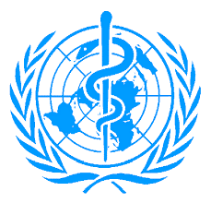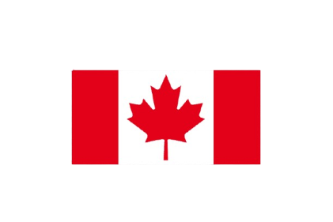**CANADA**

**Position Paper:** Canada Delegate **Committee:** World Health Organization (WHO) **Topic:** The Global Health Impacts of Climate Change and Mitigation Strategies **Delegation:** Canada

**Honorable Chair and Distinguished Delegates;**

Canada is a country in North America. It is bordered by the Atlantic Ocean to the east, the Pacific Ocean to the west, Alaska and the Arctic Ocean to the north, and the United States to the south. The country covers an area of 9.98 million square kilometers, stretching from the Pacific Ocean to the Atlantic Ocean and the Arctic Ocean in the north. With this characteristic, Canada is the second-largest country in the world by area.

Canada has been a steadfast supporter of the World Health Organization (WHO) since its establishment on April 7, 1948. It plays an active leadership role both in the Americas and in the global work of the WHO. This includes providing support and expertise in responding to health emergencies such as HIV/AIDS, H1N1 influenza, and COVID-19 pandemics, developing vaccines for Ebola, fighting polio, and advancing global health security. Canada provided significant support by hosting the Global Diabetes Summit in 2021 and has supported and implemented the WHO Framework Convention on Tobacco Control at the national level. Canada is a strong advocate for these issues within the WHO Governing Body.

Canada’s geographical diversity plays a significant role in determining its climate. Large bodies of water such as lakes and rivers are important factors in shaping the country’s geography and ecological structure. A report prepared by the Sustainable Finance Institute at Queen’s University in Kingston has highlighted the financial challenges Canada will face in the event of incidents such as biodiversity loss, rising sea levels, pandemics caused by climate change, and infrastructure damage caused by wildfires and floods. The report states that if global warming continues, the total cost of climate change to the Canadian economy by the end of this century will be between $2.8 and $5.5 trillion. The researchers concluded that "if no precautions are taken, the figures could double." Canada also proposes several solutions to reduce the negative impacts of climate change on global health:

1. **Public Education and Awareness Raising:** This should be done at the individual and societal level through educational programs, school curricula, media campaigns, and distribution activities.
2. **Protection and Expansion of Green Spaces:** Cities and towns should not neglect to create more green spaces and should ensure that existing natural areas are not deprived of adaptation to climate change.
3. **Reduction of Carbon Emissions and Investment in Clean Energy:** Canada must accelerate its transition to clean energy to reduce global carbon emissions. This will not only help mitigate global warming but also protect the air and prevent respiratory diseases.

**References:**

* <https://en.wikipedia.org/wiki/World_Health_Organization>
* <https://tr.wikipedia.org/wiki/Kanada>
* <https://www.who.int/countries/can/>