Country: Russian Federation
Commitee: SPECPOL
Agenda item: Reassessing the Political Status of Disputed and Non-Self-Governing Territories
Delegate: Kıvanç KARAKAYA
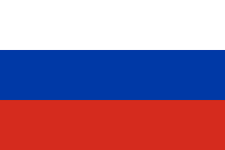

The Russian Federation finds that non-self-governing territories pose a significant threat to world peace and justice. Such challenges undermine the freedom of states and hinder the full realization of their sovereign rights. For the Russian Federation, non-self-governing territories represent a major problem to the promotion of justice and peace.
The Russian Federation recognizes this issue as a significant challenge to international peace and stability. From the perspective of the Russian Federation, the sources of this problem are colonialism and the continued existence of non-self-governing territories. The Russian Federation understands the importance of non-interference in internal affairs, and supports peaceful, state-consented and United Nations-based approaches to addressing such issues.
The Russian Federation calls for delibrations under the control and audit of United Nations. Procedures that under the consent of the sides, while not under any of political or military based pressures. For the Russian Federation, it is important to non-self-governing-terrorities are having their self determination and political stability. The Russian Federation supports the Transition models that preserve regional stability, and calls for inclusive dialogue facilitated by the United Nations to achieve sustainable and mutually acceptable solutions.

