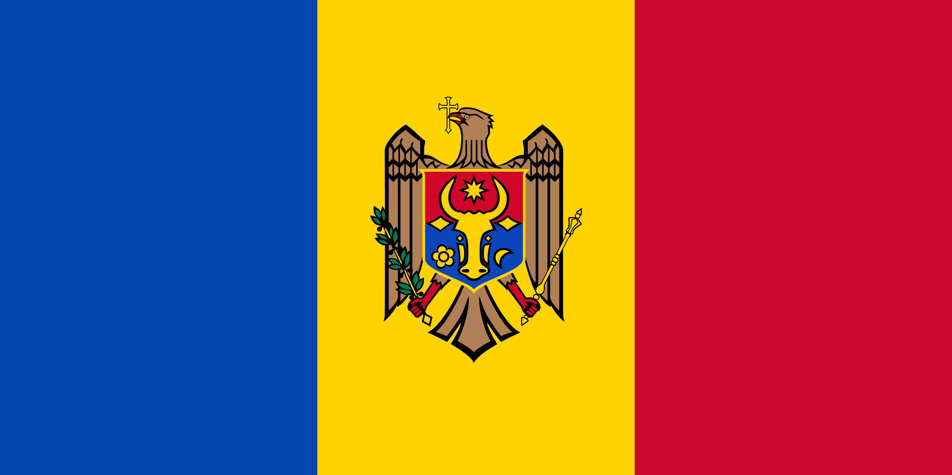
Country: Moldova
Committee: The Commission on the Status of Women
Topic: Recognition and Visibility of Transgender Women
Human rights violations and hate speech against trans women and LGBT persons caused the issue to become a global issue. As the Moldovan delegate, we are fully aware of this problem and are ready to make every sacrifice for its solution.

Lesbian, gay, bisexual, and transgender (LGBT) individuals
in Moldova may face legal and social challenges and discrimination not experienced by non-LGBT residents. Households headed by same-sex couples are not eligible for the same rights and benefits as households headed by opposite-sex couples. Same-sex unions are not recognized in the country, so consequently same-sex couples have little to no legal protection. Nevertheless, Moldova bans discrimination based on sexual orientation in the workplace, and same-sex sexual activity has been legal since 1995.
Moldovan society remains very traditional and discrimination and violence against members of the LGBT community is commonplace. In 2018, ILGA-Europe ranked Moldova 49th in terms of LGBT legislation. Thanks to its efforts, Moldova moved up 6 places in a short time and rise to 43rd place. This is an indication of how seriously we take the issue.
Moldova has shown how much it values ​​trans women and women's rights with the agreements. The Republic of Moldova acceded to the Convention on the Elimination of All Forms of Discrimination Against Women (hereinafter referred to as Convention) in 1994 and has a ‘State Party’ status within the framework of the Convention.There are also institutions opened to protect the rights of LGBT persons. GENDERDOC-M is the first non-governmental organization protecting and advancing the rights of LGBT people in Moldova. GENDERDOC-M Information Centre is the only organization that is offering legal and psychological assistance for transgender people with legal gender recognition and discrimination based on gender identity and gender expression. We maintain a support group for transgender and gender non-conforming people which aims to create a safe space for socialization and informing.
As you can see, we are aware that there are problems experienced by transgender people in Moldova, but we have full faith that we will find a solution to this problem as United Nations delegates. We hope that organizations like GenderDoc-M will increase and every citizen will be treated equally. We also have global solution proposals as a Moldovan delegate. We think that there should be a sub-organization in the united nations to defend the rights of trans women and trans people. Sub-organization will be there for them when they cannot defend themselves, and he will try to understand and solve the reason for the hate speech made against them. We also believe that the ill-treatment of transgender people through social media should be resolved.
We are ready to embark on this path and invite other delegates to break prejudices and work solution-oriented.

