POSITION PAPER

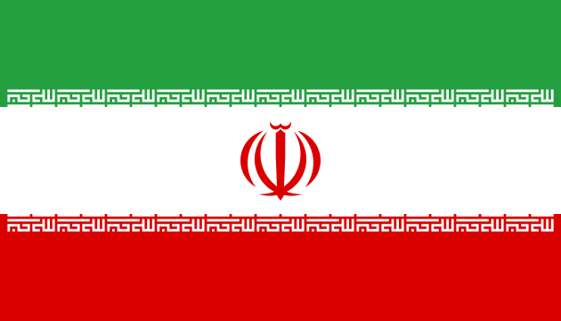 

Comitte : UNDP

Country : IRAN

Agenda Item : Strengthening the Integraton of Crisis Resilience Systems with Peacebuilding Intatves and Conflict Preventon Strateges

According to the United Nations Peacebuilding Architecture Assessment Report, If sustainable peace, which is the main goal, is to be achieved, this prevention and reconciliation and peacekeeping, as well as post-conflict recovery and reconstruction as a key shared responsibility carried out through their work must be understood." The goal is a sustainable peace in which all segments of the population can thrive. It is the creation of a situation. It's just the absence of violenceIt is a much longer-term goal than a negative peace.

Our agenda item is to strengthen the integration of peacebuilding initiatives and crisis resilience systems and to prevent conflict, and in this regard, world policy aims to ensure the permanent establishment of peace and tranquility in geographies that have been exposed to the destruction of wars, and to ensure the implementation of ceasefire agreements. However, the United Nations must prioritize human rights in peacebuildingThe colonial policy resulting from the collapses that occurred after the industrial revolution caused problems for Iran. The increase in oil prices and the developments that occurred along with it, contrary to expectations, created serious problems for the Iranian administration. The slums that emerged as a result of mass migration to the cities became the center of opposition against the administration. The foreign presence in the country, the capitation agreement signed with the USA, the significant increase in imports but the lack of measures to protect domestic producers and farmers, and the increasing unemployment brought the discontent among the masses to an explosive point. Indeed, with the "Islamic Revolution" led by Khomeini in February 1979, an era ended and a new era began in Iran. The power struggle between Bani Sadr, the first president after the revolution, and the Islamic Republic Party led by Beheshti ended in favor of the Islamic Republic Party when Bani Sadr fled abroad with Masoud Rajavi, the head of the People's Mujahideen organization, and the state administration came completely under the control of radical clerics

With the revolution, significant changes occurred in Iran's foreign policy. Iran, one of the most important regional allies of the US and a country of vital importance in the Gulf in line with Nixon's "Double Pillar" doctrine, suddenly became one of the countries most opposed to US policies, and the US Embassy in Tehran was raided by Iranian students and the embassy staff were taken hostage. The crisis that erupted between the US and Iran following this incident lasted 444 days and ended with Reagan becoming President and the hostages being released. During this period, the US organized an operation to rescue the hostages, but the operation failed due to a sandstorm in the Tabes region and the hostages could not be rescued. We believe that it would be more accurate to examine the foreign policies implemented by the new regime that came to power in Iran as a result of the Islamic revolution that took place after these developments that we have tried to summarize, regionally.

As a member of the United Nations, we think that we need to prepare a preventive policy. We think that we need to have a policy that aims to develop the world and move it to different positions, leaving political relations aside. And we think that this policy should be subject to strict control during the process. Apart from this, of course, we will all have internal and external problems because even if we apply a preventive policy, different problems may arise. We can find solutions to these problems through negotiation, dialogue and mediation. If a dialogue process functions as a regular mechanism that will ensure mutual exchange of views between the issues and dynamics that cause disagreement, it will ensure that more sustainable results are achieved. Because it establishes permanent relationships using non-violent means and creates and develops common ground over time. Mediation, on the other hand, develops constructive and interest-based approaches to the resolution of conflicts and disagreements. Mediation encourages a constructive communication culture that reduces the willingness of the parties to resort to violence and unilateral actions. If peace negotiations produce a clear and effective agreement between high-level decision-makers or leaders of the conflicting parties, they can form the basis for a non-violent, political solution, as they will be seen as an effective way to achieve the goals. We look forward to sharing these solutions with other delegates at the conference and finding different solutions.

BIBLOGRAPHIA

<https://www.qcea.org/wp-content/uploads/2019/06/Turkish.pdf>

<https://tasam.org/tr-TR/Icerik/1389/iranin_bolgesel_politikalarina_bakis>

[(PDF) Integrating Crisis Early Warning Systems: Power in the Community of Practice](https://www.researchgate.net/publication/292337423_Integrating_Crisis_Early_Warning_Systems_Power_in_the_Community_of_Practice)