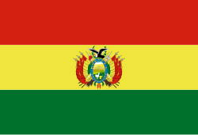 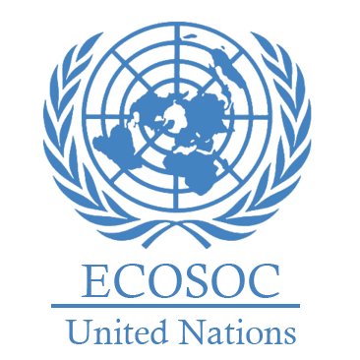

**Committee: The Economic and Social Council (ECOSOC)**

**Country:Bolivia**

**Agenda Item: Promoting Gender Equality and Empowering Women in Developing Economies.**

**Bolivia, officially the Plurinational State of Bolivia is a landlocked country located in central South America With an area of 1,098,581 km2 (424,164 sq mi), Bolivia is the fifth-largest country in South America after Brazil, Argentina, Peru and Colombia, and, alongside Paraguay, is one of two landlocked countries in the Americas. The country's population, estimated at 12 million.**

**We advocate that development should not only be based on economic development, but also on equality between people and harmony with nature. We tried to reduce poverty with social assistance (especially for mothers, students, the elderly) In order to prevent violence against women, we enacted the 'Law on the Prevention of Violence Against Women' in 2013.**

**Our economy is largely based on mining. We can further develop our economy by supporting agriculture, tourism and small businesses. Small loans can be given to our women and they can be encouraged to enter business life. More flexible working hours can be provided for our women working in rural areas.**