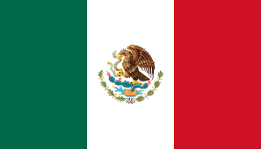***Country: United Mexican States***

***Committee: WHO***

***Agenda Item: Addressing the Ethical Dilemmas and Operational Challenges in Organ Harvesting, Including Compliance With National and International Rules and Regulations***

Mexico, officially the United Mexican States, is a country in the southern portion of North America. Mexico City is the capital of Mexico. It covers approximately 2,000,000 km2 making it the world’s 13th largest country by area, with a population of almost 130 million, it is the 10th most populous country and has the most Spanish speakers.

The matter at hand, helds an important place at global healthcare systems, since it involves the importance of organ harvesting and donation. We are aware of the role of organ transplantation in saving lives, especially in a country, for example us, where this procedure has become a critical medical way to fight illnesses such as heart problems, liver and kidney diseases etc. Mexico has made lots of progress to regulate organ donation. For a significant example, National Transplantation Law sets strict guidelines in order to prevent organ trafficking and ensure transparency in organ procurement and allocation. In addition, the **National Transplantation Center is responsible to coordinate** the national transplant system. Also, Mexico supports awareness campaigns on organ donation, in line with WHO recommendations. Mexico is also a signatory of the **Declaration of Istanbul,** committing to the ethical principles of organ donation and fighting organ trafficking and transplant tourism. As an extra, we would like to mention that Mexico supports and also encourages other governments about strengthening international regulations on organ transplantation, organ trafficking and organ shortage.

As the delegate of the United Mexican States, we’re aware of these issues and prepared to find solutions in no time in order to prevent these problems from occurring. As we mentioned before, we highly encourage other delegates to come up with ideas as much as they can in order to strengthen our weak areas.