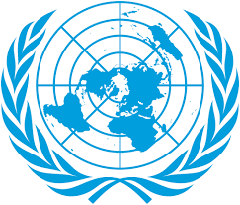
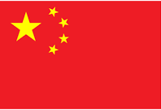

Committee: WHO -2
Agenda Item: Addressing Health Issues Caused by Air Pollution
Country: China
Delegate: Nazenin YILDIZ

China is in eastern Asia and on the western coast of the Pacific Ocean. China is the largest country in Asia and the third largest in the world after Russia and Canada. China has a population of 1,414,632,820 people.
Air pollution in China is one aspect of the broader environmental problems in the country. Due to China's large population, industrialization has increased. Following industrialization, various types of pollution have increased, causing widespread environmental and health problems. For example, in Shanghai, the economic powerhouse of China on the east coast, there is intense air pollution due to harmful substances released from factories via river currents; air pollution in Beijing is another example.
To give an example of China's work on these issues; after the 'air disaster' in Beijing sparked a wave of anger and frustration among citizens, China took action to improve air quality in its cities and shut down a number of old power plants in the most polluted regions, including the Beijing-Tianjin-Hebei city clusters and the Pearl and Yangtze Deltas.

References: Wikipedia, UNEP Emissions Gap Report, Blue Sky Protectiom Campaign documents, World Bank Air Quality Management Reports

