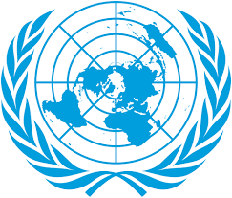
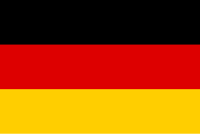

Committe: ECOSOC ( The United Nations Economic and Social Council )
Agenda Item: Combating Child Labor and Promoting Fair Opportunities For Youth
Country: Germany
Delegate: Elif Gökçe DEMİREL
Germany is in Europe. Its capital city is Berlin. 83 million peopse live there. Its currency is Euro. And the official language is German. It has a good economy and a good education system.
Child labor is a serious in Germany. It affects millions of children. Many children have to work in dangerous conditions and can’t go to school. This is really bad for their physical and physicological development. ECOSOC is really important in protecting children’s rights.And it promotes education for all. Germany strongly believes that child labor must be eliminated.Germany is a developed country,so it has strict national laws that protect children. In Germany, children under the age of 15 can't work. Also Germany accepted ILO Conventions No.138 and No.182. They aim to end child labor and the worst forms of child labor world wide. However, Germany supports responsible business practices to prevent child labor in global supply chains.
Germany works hard to fight child labor and to protect children from working. And it makes sure that they go to school. Also families need financial support, so children don’t have to work. Germany asks other countries to strengthen their laws, improve access to education, and cooperate internationally. To end child labor, the governments need teamworks, international organizations and private sector.

References: Wikipedia, UNICEF, pronats.org ,World Bank
https://pronats.org/en/information/childhood-and-work/child-labour-in-germany https://www.ilo.org

