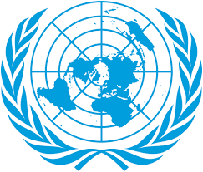
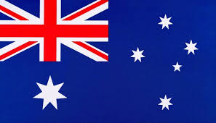
Country: New Zealand
Committee: World Health Organization-2 (WHO-2)
Agenda Item: Addressing Health Issues Caused by Air Pollution
Delegete: Zehra Nur DEDE

New Zealand is an island country in the South Pacific Ocean. Its capıtal city is Wellington. It doesn’t have any land borders. The population is nearly 5.3 million. The population includes Europeans and the native Maori people. The country is famous for its farming. They sell a lot of milk, meat and wool to other countries. Also, many tourists visit New Zealand to see its beautiful nature. New Zealand has a melt climate, but the weather can change very fast. Because it is in the Southern Hemisphere, the seasons are opposite to Europe or North America.
New Zealand is famous for its clean and green image, but it still has some air quality problems. According to LAWA, most of the dangerous particles in the air comes from home heating and traffic. For example, about 80% of air pollution comes from home heating with burning wood and coal in some small towns. This makes it hard for people with asthma to breathe, lung diseases and heart problems. The country has one of the highest rates of asthma in the World. Also while the country looks green, 40% of emissions come from transport. In big cities like Auckland, there are too many cars. And they release harmful gases into the air. Every year, air pollution causes around 3300 premature deaths in New Zealand.
New Zealand tries to solve these serious problems in different ways. The government supports clean energy such as wind and solar power. Also people are willing to use public transport and electric cars instead of private cars. Beside these, the factories aren’t allowed to release too much smoke to the air and the government checks them to give fines if they don’t follow the rules. Another example is heating. There are some rules about what kind of heating systems people can use. Especially in winter, cleaner systems are prefered. There is also Environment Minister who works with other institutions to protect public health and the environment. However, New Zealand has a special day about air pollution. It is called “ Clean Air Day” and people learn about clean air and health on this day in September. This day helps to raise awareness about clean air and healthy living.
New Zealand believes that people should be informed about how air pollution affects their heaalth, especially through schools and public campaigns. And factories have important place in industrial production around the world but they should be checked more often around the world. Finally, cooperation with other countries is important to reduce air pollution and protect human health. This helps make world a healthier place for everyone.

References: Wikipedia, Environmental Health Indicators- Air Quality/HAPINZ, WHO- Air Pollution, LAWA, Ministry for the Environment

