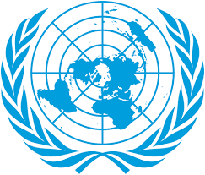
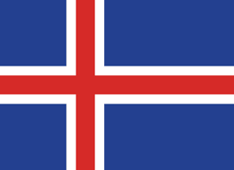
Country: Iceland
Committee: UNCSTD-2
Agenda Item: The Role of Technology in Combating the Climate Crisis
Delegate: Melih Emre YILMAN

Iceland is located in North Atlantic Ocean between North America and Europe, which makes it an island country. Iceland has a rough and cold climate due to being in Scandinavia which makes its climate colder. It has a population of nearly 400 thousand people. The main and most common source of income in Iceland's economy is fishing and fish products. Thermally welded tourism and winter tourism are the most common ones in Iceland when it comes to tourism. It has the least unemployment rate in Europe with %0,8 unemployment rate. Its enflation rate is %6,8.
The climate change is a serious global issue that effects many ecosystems. Many countries are trying to solve this problem including Iceland. Iceland is determined to achieve carbon neutrality before 2040 and to cut greenhouse gas emmisions by 40% by 2030 under the Paris Agreement with carbon capture technologies and share their clean energy expertise with other nations. The international organizations are helping countries to solve this problem with their projects. Iceland knows their responsibility as a developed country and supports developing countries such as afghanistan , morroco and egypt who wants to develope their climate change technologies and provides them financial and technical support with other developed countries, so they can fight this problem together.
Iceland has done so many projects to fight the climate change. The most important ones of these was carbon capture technologies. Their goal is to become carbon neutral by 2040 and they want to develope their technology against the climate change with other countries together and spread these technologies all around the world to reduce the climate change. So they need the support of the international organizations to make this happen. Iceland expects them to support their project.

References: Wikipedia, Britannica, international list of developing and developed countries, Government of Iceland,

