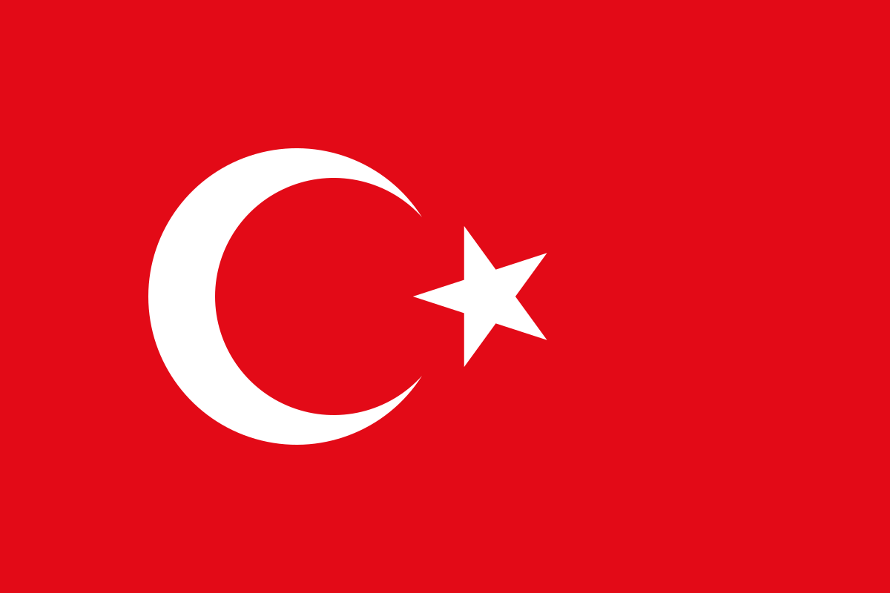

Conference: TEDUTRAIN 2024

Commitee: SOCHUM

Agenda Item: Curbing Human Trafficking, Child Labor and Terrorism in Cultural Properties

Country: Türkiye

Delegation: Mehmet Emin Resulzade Anatolian High School

Delegate: Arya Erpolat

We as Türkiye know the hazardous impact of human trafficking, Child Labour and

terrorism in cultural properties on global peace, human rights, and development and that these cruel acts need to be curbed and terminated. As a country that made and still making effort to combating on these inhuman critical issues we are ready to support global efforts to combat these violations and are highly encouraging everyone to cooperate for eradicating these doings.

Human trafficking is one of the most serious forms of human rights abuse, Human trafficking constitutes a violation of human rights and an offense to the dignity and the integrity of the human being, and is mostly referred as "modern day slavery", and is known to be the third most profitable organized illegal activity following drugs and arms trafficking. It has been acknowledged that the problem needs to be tackled seriously and immediately. Türkiye is a major destination country in human trafficking due to its geographical location and higher level of prosperity relative to its neighboring countries. Those trafficked to Türkiye are mostly citizens of former Eastern Block countries that have low average national incomes per individual person. Although human trafficking in Türkiye mostly involves the sexual exploitation of women and girls, when determining its strategy for combating human trafficking, Türkiye always considers the fact that men, as well as women and children, are harmed by this crime. Türkiye introduced numerous administrative and legal measures regarding the main pillars of combating human trafficking, prevention, protection, prosecution, and cooperation. The Turkish Government works closely with civil society to support and assist victims of human trafficking.

To this end, “The National Task Force on Fight against Human Trafficking” was established in 2002.

This Task Force, which comprises relevant government agencies and NGOs, plays a crucial role in shaping policies aimed at preventing human trafficking, identifying and protecting victims, and prosecuting traffickers.

Child labour remains a significant challenge in sectors such as agriculture, domestic work, and informal industries. Türkiye has made significant progress of reducing the child labour during the last three decades yet challenges persist, especially in rural areas. Our journey towards this milestone began in 1992 when it became one of the first six countries to participate in the International Labour Organization's (ILO) International Programme on the Elimination of Child Labour (IPEC). After that, Türkiye ratified important international conventions such as the UN Convention on the Rights of the Child and various ILO conventions related to child labour. Over the years, Türkiye has implemented comprehensive national programs aimed at eradicating child labour, culminating in the successful reduction of child labour rates from 15.2% in 1994 to 4.4% in 2019 among children aged 5-17. In 2024, Türkiye's efforts were further recognized as it officially became an Alliance 8.7 Pathfinder Country, joining a global coalition dedicated to achieving UN Sustainable Development Goal Target 8.7, which aims to end child labour, forced labour, modern slavery, and human trafficking by 2025.

Terrorism in cultural properties is a very important issue that needs to be curbed. It can harm society because a portion of cultural identity,scientific facts and historical facts can be lost. One of the most important things to people is their culture and their cultural heritages can be destroyed by terrorism in cultural properties.Türkiye has been the cradle of different civilizations throughout  history. Consequently Türkiye is one of the richest countries in the world as regards historical monuments, artifacts and ruins. This makes Türkiye a target of illegal trafficking of antiques and artifacts which are smuggled out of Türkiye and displayed in several leading museums and private collections in the world. Measures taken by the competent Turkish authorities, have resulted in the restitution of many of the illegally exported cultural property from Türkiye.

Exporting cultural property from Türkiye illegally is an offence subject to punishment.

In conclusion for human trafficking, Türkiye suggest an approach that includes prevention, victim support, law enforcement, and international cooperation. Regarding child labour, Türkiye supports strengthening national legislation, improving access to education, and international partnerships to reduce child labour globally. Lastly, Türkiye supports safeguarding cultural heritage and preventing it being abused by terrorist organizations, working with international organizations to improve the protection of cultural properties for future generations. We would like to negotiate solutions with other delegates and we are open to cooperations for a more peaceful world.

Bibliography

*Türkiye on Trafficking in Human Beings / Republic of Türkiye Ministry of Foreign Affairs*. (n.d.). Republic of Türkiye Ministry of Foreign Affairs. <https://www.mfa.gov.tr/turkiye-on-trafficking-in-human-beings.en.mfa>

*Türkiye recognized as pathfinder country in global fight against child labour*. (2024, May 27). International Labour Organization. https://www.ilo.org/resource/news/turkiye-recognized-pathfinder-country-global-fight-against-child-labour

*Fight against the Illegal trafficking of cultural heritage / Republic of Türkiye Ministry of Foreign Affairs*. (n.d.-b). Republic of Türkiye Ministry of Foreign Affairs. <https://www.mfa.gov.tr/fight-against-the-illegal-trafficking-of-cultural-heritage.en.mfa>

<https://www.mfa.gov.tr/data/DISPOLITIKA/2006_human_trafficing.pdf>

<https://www.unicef.org/turkiye/en/press-releases/ending-child-labour-national-priority-t%C3%BCrkiye>