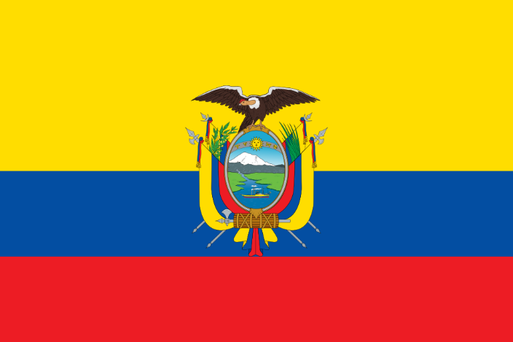

Conference: ETUTRAIN 2025

Commitee: ECOSOC

Agenda Item: Promoting Gender Equality and Empowering Women in Developing Economies.

Country: The Republic of Ecuador

Delegation: Mehmet Emin Resulzade Anatolian High School

Delegate: Arya Erpolat

Ecuador recognizes that gender equality and the representment of women in the is not only an essential human right but also a neccesarry thing to achieve an inclusive and sustainable environment. We are informed that - the path for a better world goes through everyone regarding their gender, ethnicitiy, beliefs everyone should be treated equally. Women are important and needed everywhere, they can create wonderful things when given the opportunity and not given the oppotunity we can always see them fight. In developing countries women face challenges such as gender-based discrimination, limited access to education and employment underrepresentation in politics and violence against women. We support the idea of making an approach that gives everyone equal rights, education, health access, aconomic opportunity that protects them legally. We believe that the only way to acheve these goals, make the world a better place for women and include them in decision making, we should collaborate and cooperate around the World. These hazardous acts and unpleasent situations can and should be stopped, if not decreased by countries working together to find solutions. We should promote women’s role in leadership positions and their political participation by that the democracy with strengthen. Clear evidence reveals that how women’s presence in leadership roles are essential for a better society like legislation against domestic violence, women’s right to health, labor rights as well as maternity and paternity rights, among others. Even though the worls has made a certian progress regarding the womens includence in leadership positions, we still can’t say that some problems are over. Women still face stereotypes that is made to bring them down from their full potential while running fort he leadership positions. Most political parties don’t promote women candidates on individual ballots nor list them heading an office-bloc ballot. Political violence and gender distribution of work make women participate less and in a sustained way in politics and leadership. It is necessary to change these conditions in a better way which that women can participate and take a role in decision making process.. The limited presence of women in spaces where economic policies are decided—and the narrow view that markets are the only source of economic value—have created a system that often excludes women. As a result, women are pushed into dependent and lower-status roles in the labor market. At the same time, they play a crucial role in non-market areas, especially in caregiving, which is often overlooked and undervalued. They also work in heavy work conditions compared to men. According to figures reported by INEC [National Institute of Statistics and Census] (2012), women worked an average of 15 hours and 47 minutes more than men in a week. In the rural area, the number would go up to a total of 23 hours more than men. We support programs that help women build skills and start productive projects that improve their quality of life and teh inclusion of gender equality in national and local economic plans and policies. We should Show effort to include gender equality in labor laws, social protection systems and related policies. We encourage the collection of data and the recognition of unpaid care work by assigning it economic value, so it can be properly acknowledged and supported.

The 2008 Constitution of Ecuador promoted the principles of equality and non-discrimination based on gender, and guarantees equal access to opportunities, resources, and political representation. The Organic Law on the Prevention and Eradication of Violence Against Women (2018) has been a critical tool in addressing gender-based violence, establishing protective measures, specialized courts, and support services for survivors. Ecuador encourage swomen on economics through partnerships with the Banco de Desarrollo del Ecuador (BDE) and local municipalities, Ecuador has promoted microloans and technical assistance to women-led cooperatives in agriculture, textiles, and crafts. The "Impulso Mujer" program offers financial education and entrepreneurship support to thousands of women, especially in rural and marginalized urban areas. Ecuador has made considerable progress in closing the gender gap in basic education, and continues to invest in secondary and tertiary education, particularly in STEM fields for girls.

Reproductive health services have been expanded, including free maternal health care and family planning programs, although access remains limited in remote regions.

We support the idea to the future acts to make women access to land, financial services, and technology for women farmers and entrepreneurs. Social protection systems for informal workers, where women are represented quite often. We can and should be in an international cooperation in order to achieve these goals, we are ready to change our countrys and the worlds situation that it is right now.

Bibliography

*Ecuador*. (n.d.). UN Women – Americas and the Caribbean. <https://lac.unwomen.org/en/donde-estamos/ecuador>

Wikipedia contributors. (2025b, April 17). *Women in Ecuador*. Wikipedia. <https://en.wikipedia.org/wiki/Women_in_Ecuador>

*Chaper 11 - Country report on Ecuador*. (n.d.). <https://cidh.oas.org/women/Ecuadorchaper%2011.htm>

*UN Women Transparency Portal*. (n.d.). UN Women Transparency Portal. <https://open.unwomen.org/en/our-reach/EC/XM-DAC-41146-ECU_D_1.1?>

Unops. (2024, July 24). *UNOPS and UN Women join forces to build a diverse and inclusive future in Ecuador*. UNOPS. <https://www.unops.org/news-and-stories/news/unops-and-un-women-join-forces-to-build-a-diverse-and-inclusive-future-in-ecuador>

*Ecuador*. (n.d.-b). Women in Local Government. https://localgov.unwomen.org/country/ECU