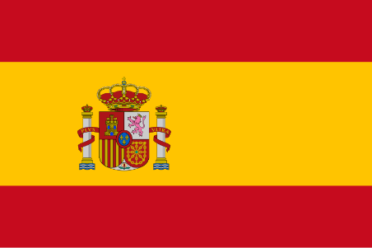Committee: SOCHUM

Country: Spain

Agenda Item(s): Curbing Human Trafficking,Child Labor and Terrorism in Cultural Properties

Degelate: Defne GÖLGEDAR

Spain is a country which is located in Europe. It is a country which has a total area of 505,990 kilometer squares, making it the fourth-largest country in Europe. The southern and eastern parts of the Spanish mainland, with the exception of the diminutive British enclave of Gibraltar, are almost completely surrounded by the Mediterranean Sea; the northern part has France and Andorra along with the Bay of Biscay, whilst the Atlantic Ocean and Portugal occupy the western part. The capital of Spain is Madrid. The official language is Spanish. according to the latest census conducted in 2023, the population of Spain is 48.37 million.

Spain has also embraced the principles of combating and preventing human trafficking and child abuse, child labor as well as children trafficking for sexual purposes and other cultural terrorism activities. It is worth noting that, the country is highly regarded by the European Union and the UNESCO, which established strong laws and also works alongside Europol and other agencies to prevent the trafficking of cultural heritage and artifacts. Likewise, in Spain, the cultural and intellectual property has received protection with the 2021 Law for the Protection of Cultural Heritage, which also applies to the use of cultural properties. Moreover, the government provides social services to enable communities address the underlying problems that lead to child trafficking as poverty and illiteracy. It has also been able to make recommendations to the rest of the world as these countries try to solve the problem of child trafficking and other related issues through dissemination of information and establishing sharing mechanisms on the importance of cultural heritage. Bearing this in mind, I, Spain, am ready to work with the nations of the world towards the safeguarding of the cultural and historical heritage of regions and nations under threats posed by humanitarian or cultural terrorism.

BIBLIOGRAPHY

<https://en.wikipedia.org/wiki/Spain>

<https://ec.europa.eu/anti-trafficking/member-states-0_en>

<https://www.ohchr.org/>

<https://en.unesco.org/>