**POSITION PAPER**

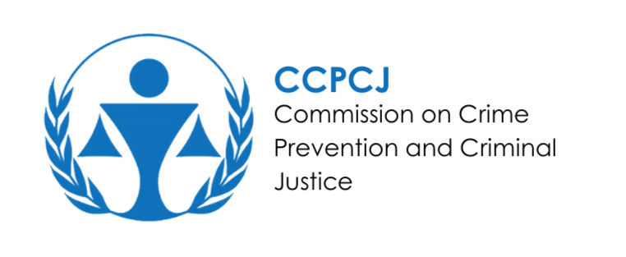

**Committee: CCPCJ (Commission on Crime Prevention and Criminal Justice)**

**Country: South Korea**

**Agenda Item: Fighting Against New Emerging Crimes**

As the South Korean state, we would like to say that we are aware of the new crimes that have emerged with the developing world and that we are trying to do everything we can in the best way possible. Organizations, agreements, and collaborations are our priorities. As a developed country, we are determined to provide assistance to countries in need. We invite all countries to meet on a common ground**.**

South Korea is one of the countries that has made its stance on preventing crimes the most obvious. Our collaborations on this issue. We actively participated in the 33rd Crime Prevention and Criminal Justice Committee (CCPCJ) meeting organized by the United Nations Office on Drugs and Crime (UNODC) held in Vienna in 2024, and demonstrated our international cooperation and technological innovations in combating new and rising crimes. At the meeting, our South Korean representative Dae-Hoon Kwak presented the connections between the Korean Penal Code and the International Crimes Code (ICCS) by analyzing them. This study will allow for the comparison of crime data and its harmonization with sustainability. In addition, South Korea organized an event discussing the role of online justice in combating crime in the digital age and called for stronger cooperation in combating online crimes. This event played an important role in the development of crime prevention and criminal justice policies. South Korea has set harsh penalties for the production, distribution and consumption of deepfake content. With the legal changes made in 2010, viewing or possessing fraudulent content is punishable by up to three years in prison or a significant fine. In addition, the penalty periods have been increased in cases such as forced labor targeting children. These laws are considered an important step in the fight against digital sexual crimes. Public awareness activities are being carried out to prevent the spread of fraudulent content. Public service announcements and educational programs with the participation of celebrities aim to raise public awareness about digital sexual crimes. In addition, stricter controls and penal sanctions are being implemented to prevent the spread of unauthorized content on social media platforms.

It is in our hands to ensure the security of our future. We must fully support the new generations for a healthy and developed world. We must not neglect to carry out our work to minimize both environmental and organized crimes and technological crimes that have developed in recent years, even if it is impossible to eliminate them.

**Sources:**

<https://www.unodc.org/unodc/en/commissions/CCPCJ/session/31_Session_2022/ccpcj-thematic-discussions_crimes-that-affect-environment.html>

<https://coekostat.unodc.org/coekostat/en/news/2024-kccs-seminar.html>

<https://coekostat.unodc.org/coekostat/en/news/global-dialogue-on-crime-and-criminal-justice_-insights-from-the-33rd-ccpcj-in-vienna.html>

<https://www.koreatimes.co.kr/southkorea/politics/20241021/south-korean-presidentyoon-calls-for-enhanced-police-efforts-to-tackle-emerging-crimes-and-deepfakes>