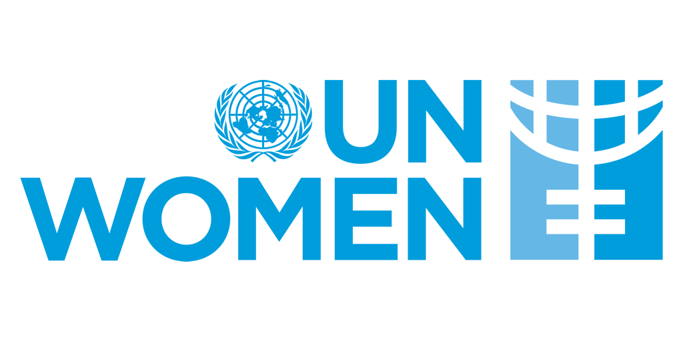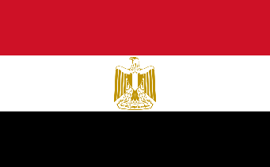**POSITION PAPER**

**Committee:** UNWOMEN

**Country:** Egypt

**Agenda Item:** Addressing Femicide Through Legislative Action and International Cooperation

As the Egyptian delegate, we are faced with this inhumane problem that concerns not only our country but the entire world. Gender inequality is a major problem that has come from ancient times. Although humanity still thinks that femicide is a tradition, it is actually a violation of our most important right, the right to life.

As the Egyptian state, we are trying to address these issues as much as we can. We are adjusting our constitutions according to the principles of equality and giving the necessary punishments to the defendants. Egypt acknowledges the existing gender disparities and has taken significant steps to promote women’s rights. The 2014 Egyptian Constitution enshrines gender equality and prohibits all forms of discrimination. Egypt was also one of the first countries to launch a National Strategy for the Empowerment of Egyptian Women 2030. Egypt has launched multiple national campaigns and helplines in partnership with civil society and UN agencies. The National Committee for the Eradication of Female Genital Mutilation (FGM) and the National Strategy for the Elimination of Violence Against Women represent serious institutional efforts. In 2021, Egypt passed laws to protect the identity of survivors and encourage more women to come forward.

Femicides mean destroying a generation. That is why we are trying to provide quotas for our women not only in politics and economy but also in every field. However, we think that this situation will improve with international cooperation. In this case, we are ready to support the initiatives of all countries that support this issue in order to guide our people and to renew our policies and take more productive steps for the future. Femicides and protecting women's rights are among the most important responsibilities. We invite all countries to find a solution