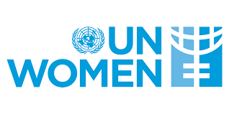 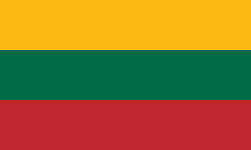

Committee: United Nations Entity for Gender Equality and the Empowerment of Woman (UNWOMAN)

Country: Lithuania

Agenda Item: Addressing FemicideThrough Legislative Action and International Cooperation

Lithuania, officially the Republic of Lithuania, is a country in the Baltic region of Europe. It is one of three Baltic states and lies on the eastern shore of the Baltic Sea. Lithuania covers an area of 65,300 km2 (25,200 sq mi), with a population of 2,89 million.

Femicide is a really serious problem in today's world. It is unacceptable but it is quite common around the world. Most countries in Europe have this problem. Lithuania has a higher rate of femicide than other European countries. The number of such incidents is increasing day by day, especially in rural areas.

As Lithuania we admit that we are having difficulty in dealing with femicide. And we know that we need to pay more attention to this topic but we strive to improve ourselves. The causes of femicide in Lithuania are often based on the social structure of society. We know that we ned to make more effective laws and do more work to raise our society’s awareness on this issue. In order to raise public awareness, we can make presentations about the seriousness of this issue in schools, courses or public areas. But it will not be effective worldwide if we do this alone. That is why we invite other countries to make such informative presentations. And we believe that if we work together we can overcome this. In this issue cooperation is very important. We are open to any kind of cooperation with other countries.