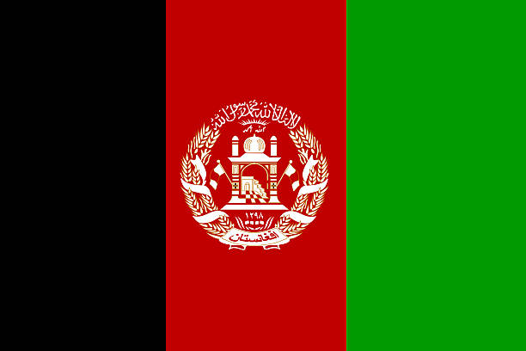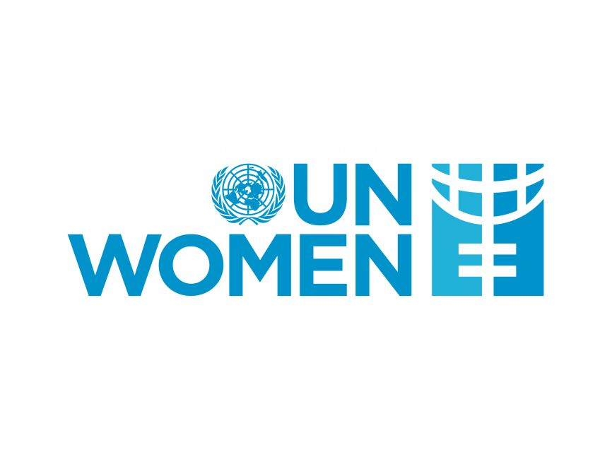

**Country: Islamic Emirate of Afghanistan**

**Committee: United Nations Entity for Gender Equality and the Empowerment of Women**

**Agenda Item: Addressing Femicide Through Legislative Action and International Cooperation**

Afghanistan, officially the Islamic Emirate of Afghanistan, is a [landlocked country](https://en.wikipedia.org/wiki/Landlocked_country" \o "Landlocked country) located at the crossroads of [Central Asia](https://en.wikipedia.org/wiki/Central_Asia) and [South Asia](https://en.wikipedia.org/wiki/South_Asia). It is bordered by [Pakistan](https://en.wikipedia.org/wiki/Pakistan) to the [east and south](https://en.wikipedia.org/wiki/Durand_Line" \o "Durand Line), [Iran](https://en.wikipedia.org/wiki/Iran) to the [west](https://en.wikipedia.org/wiki/Afghanistan%E2%80%93Iran_border" \o "Afghanistan–Iran border), [Turkmenistan](https://en.wikipedia.org/wiki/Turkmenistan" \o "Turkmenistan) to the [northwest](https://en.wikipedia.org/wiki/Afghanistan%E2%80%93Turkmenistan_border" \o "Afghanistan–Turkmenistan border), [Uzbekistan](https://en.wikipedia.org/wiki/Uzbekistan" \o "Uzbekistan) to the [north](https://en.wikipedia.org/wiki/Afghanistan%E2%80%93Uzbekistan_border" \o "Afghanistan–Uzbekistan border), [Tajikistan](https://en.wikipedia.org/wiki/Tajikistan" \o "Tajikistan) to the [northeast](https://en.wikipedia.org/wiki/Afghanistan%E2%80%93Tajikistan_border" \o "Afghanistan–Tajikistan border), and [China](https://en.wikipedia.org/wiki/China" \o "China) to the [northeast and east](https://en.wikipedia.org/wiki/Afghanistan%E2%80%93China_border" \o "Afghanistan–China border). Occupying 652,864 square kilometers (252,072 sq mi) of land, the country is predominantly mountainous with plains [in the north](https://en.wikipedia.org/wiki/Afghan_Turkestan) and [the southwest](https://en.wikipedia.org/wiki/Sistan_Basin" \o "Sistan Basin), which are separated by the [Hindu Kush](https://en.wikipedia.org/wiki/Hindu_Kush) mountain range. [Kabul](https://en.wikipedia.org/wiki/Kabul) is the country's capital and largest city. [Afghanistan's population](https://en.wikipedia.org/wiki/Demographics_of_Afghanistan" \o "Demographics of Afghanistan) is estimated to be between 36 and 50 million.

Femicide has emerged as arguably the single most important focus for both gender programming and women’s rights activism in Afghanistan over the past decade. Efforts to counter such violence have mainly sought to strengthen criminal accountability through reforms of the law, the courts, the prosecution and the police. This strategy is based on the recognition that an important cause of violence against women in contemporary Afghanistan is the prevailing tendency to consider such violence a private matter rather than a criminal act. Progress to strengthen accountability, however, has been slow, despite the enactment of a landmark law on Elimination of Violence Against Women (EVAW) in 2009. The vast majority of cases, even if registered with the prosecution, fail to make it through the criminal justice system, including murders of women. The complex reasons for this high rate of attrition are as yet not well understood and form the subject of this research project. Since the fall of Taliban regime in 2001, the government of Afghanistan, in a bid to promote human rights and specifically women’s rights, made several legislative and institutional advances. These included the establishment of the Afghanistan Independent Human Rights Commission (AIHRC) as a national human rights institution, Ministry of Women’s Affairs, Departments of Women’s Affairs and Gender, Human Rights Units in various ministries and the passing of the Law on Elimination of Violence against Women (EVAW Law) through a Presidential Decree in 2009. Afghanistan is a signatory to several international human rights instruments, including the *Convention on the Elimination of All Forms of Discrimination against Women* (CEDAW). International treaties and Conventions to which Afghanistan is a signatory forbid all types of discrimination against girls and women and oblige Afghanistan to eliminate all types of discrimination, violence and other possible detrimental practices against women.

The project will use a dual approach. First, it will map the course of registered cases as they pass through the legal process, disaggregating them by type of incident and outcomes. This will provide important data on what types of violence against women (VAW) incidents are most commonly registered with the prosecution, and what offenses have the highest and lowest attrition rates through the legal chain. Secondly, in four sample provinces, we will map the reasons for why individual VAW cases exit the criminal system. This will help us identify the factors influencing the failure to move from registration to prosecution and/or conviction, such as withdrawal of complaint, lack of evidence, quality of the legal defense, the judges’ interpretation of the law or ideological outlook, or extra-legal considerations such as family relations, political pressure or bribes.Finally, as part of this qualitative research we shall systematically consider the legal basis for convictions as well as the socio-political identity and status of convicted perpetrators and victims.

In addition we suggest more solutions. Firstly we must organize education campaigns. It would include details and it should be effective . Therefore this campaigns also covers rural places that needy for this. Competent people must have make an effort for this. Furthermore Sivil Society Organizations could be   
beneficial for project. Due to it can help easily to community and also it would raise collaboration in international . Besides it should provide urgent services as psyhcological support etc. Moreover social media can be use for this because nothing can spread mindset shift faster than social media obviously . And we must provide safe places for our women. And lastly, we have to international organizations to make a pressure and raise awereness as UN and EU.

References:

<https://link.springer.com/article/10.1007/s40901-020-00116-x>

<https://en.wikipedia.org/wiki/Afghanistan>

<https://www.cmi.no/projects/1799-violence-against-women-and-criminal-justice-in>

<https://www.unwomen.org/en/what-we-do/ending-violence-against-women/take-action/commit/government-commitments>