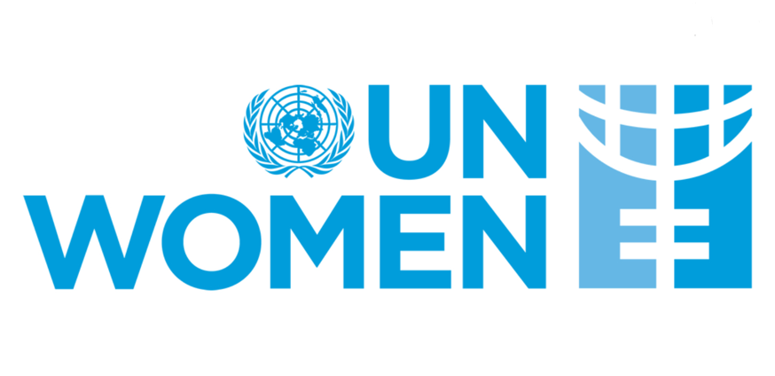

Country: Indonesia
Committee: UNWOMEN
Delegate: Dora Döğüşcü
Agenda Item: Protecting women in the age of digital abuse: Regulating AI, Deepfakes, and Online Gender-Based Violence
As a member of United Nations, Indonesia explicitly supports gender equality and advences projects to protect it. An example of this is the “Ring the Bell for Gender Equality” initiative, which has also been documented UNWOMEN. Indonesia is a rapidly growing, multifaceted country, which means that women need to be more vigilant against abuse in online environments and require protection from the government. Our government has enacted laws to combat cybercrime and created projects to protect female citizens from online harassment. Protecting our people, especially our female citizens, is our top priority and working towards this goal is our responsibility. Indonesia held a workshop in 2023 for young citizens on cyber bullying and raising awareness about protecting themselves in online environments. The workshop concluded with a competition in which the participants used skills they learned to create content about online gender-based violence, misinformation and women politicians. They uploaded the content on social media in order to raise awareness around the world and this project has been also noticed by UNWOMEN.
In today's world, the negative discrimination and bullying that women face, both online and in social settings, is absolutely unacceptable to us. As governments, raising awareness in our societies about this issue and creating safe environments for everyone should be our priority. UNWOMEN Indonesia works with a range of stakeholders to increase awareness of the causes and consequences of violence against women, while also building the capacity of partners for policy reform to prevent and respond to this violence. We advocate for changing norms and behavior as a prevention strategy to tackle violence against women. As Indonesia, we proudly look forward to finding more effective solutions and hopefully going through an efficient process to get ahold of gender-based violence and discrimination on women more.
Bibliography/References:
https://asiapacific.unwomen.org/en/stories/news/2024/05/how-to-respond-to-online-gender-based-violence-against
https://asiapacific.unwomen.org/en/countries/indonesia
https://asiapacific.unwomen.org/en/stories/feature-story/2024/05/indonesia-rtb-calls-for-investment-in-womens-economic-empowerment

