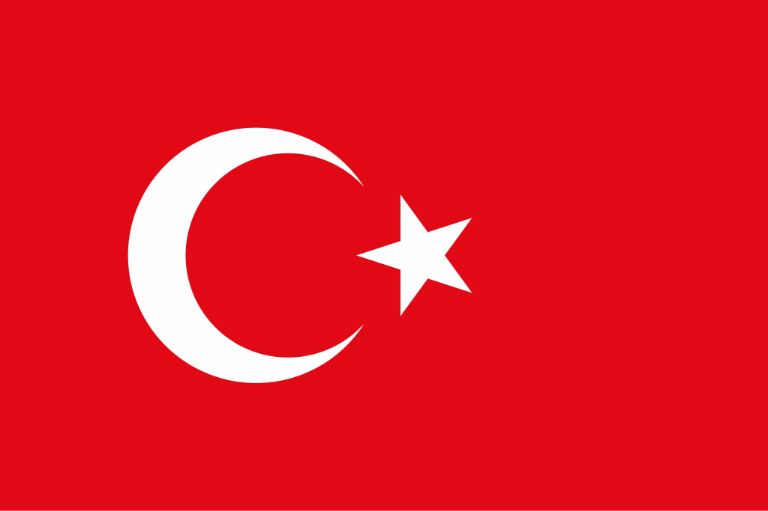
Country:The Republic of Türkiye
Committee:UNESCO (United Nations Educational Scientific and Cultural Organization
Agenda Item: Addressing Illicit Trafficking and Protection of Cultural Property

The Republic of Türkiye is a country located in Anatolia and Western Asia, with a small part in Southeast Europe It’s bordered with the Black Sea, Georgia, Armenia and Azerbaijan to the east and Iraq, Syria and Mediterranean Sea to the south with the Aegean Sea,Greece and Bulgaria to the west. The population of Türkiye is approximately 88 million while having Kurds as the largest ethnic minority. Türkiye has an official secular state but a Muslim-majority population. The capital of Türkiye is Ankara, which is also the 2nd biggest city with Istanbul as the first. Türkiye is a upper middle income country that is emerging.
Türkiye has the World’s 16th nominal and 11th largest PPP-adjusted GDP. Türkiye is the founding member of many organizations like OECD,G20 and Organization of Turkic States. With having a great geopolitically significant location, it is also a member of NATO. It has the second largest military in NATO after the United States of America.

Türkiye has made lots of progress in fighting the illicit trafficking of cultural property and ensuring better protection of its cultural heritage. Being at the crossroads of different civilizations makes Türkiye a country that has always faced problems of illegal excavation and trafficking of cultural property. Other factors which make Türkiye vulnerable to threats to cultural property and infrastructure include instabilities in the neighboring region and displacement of persons. To address these problems, Türkiye has attempted to build its capacity and legal structures in dealing with illegitimate activities at its borders and has
participated in various UNESCO agreements, such as the 1970 Convention on the Means of Prohibiting and Preventing the Illicit Import, export and Transfer of Ownership of Cultural Property.

The international community recognizes illicit trafficking of cultural property as a serious global problem, especially in areas affected by conflict. Ongoing situations such as Palestine and Ukraine show how war increases the destruction, looting, and illegal sale of cultural heritage. Organizations like UNESCO and INTERPOL work to protect cultural sites and prevent trafficking, but weak enforcement and limited access to conflict zones remain major challenges. Member States should increase cooperation by sharing information, strengthening border controls, and monitoring art markets more closely. Supporting countries affected by conflict, improving documentation of cultural property, and enforcing existing international agreements are key steps. Türkiye supports collective action under UNESCO to protect cultural heritage and prevent its illegal trade.
BIBLIOGRAPHY:

https://www.unesco.org.tr/Pages/659/314/UNESCO-World-Heritage-List

https://www.worldometers.info/world-population/turkey-population/

https://www.un.org/sustainabledevelopment/sustainable-development-goals/

https://en.wikipedia.org/wiki/Turkey

https://kids.nationalgeographic.com/geography/countries/article/turkey#:~:text=use%20is%2 0prohibited.-
,Turkey%20is%20a%20large%20peninsula%20that%20bridges%20the%20continents%20of
,land%20in%20the%20Bosporus%20seaway.

https://en.wikipedia.org/wiki/Demographics_of_Turkey

https://en.wikipedia.org/wiki/Gaza_war

https://www.aljazeera.com/tag/israel-palestine-conflict/

https://www.aljazeera.com/tag/ukraine-russia-crisis/

https://www.bbc.com/news/war-in-ukraine

