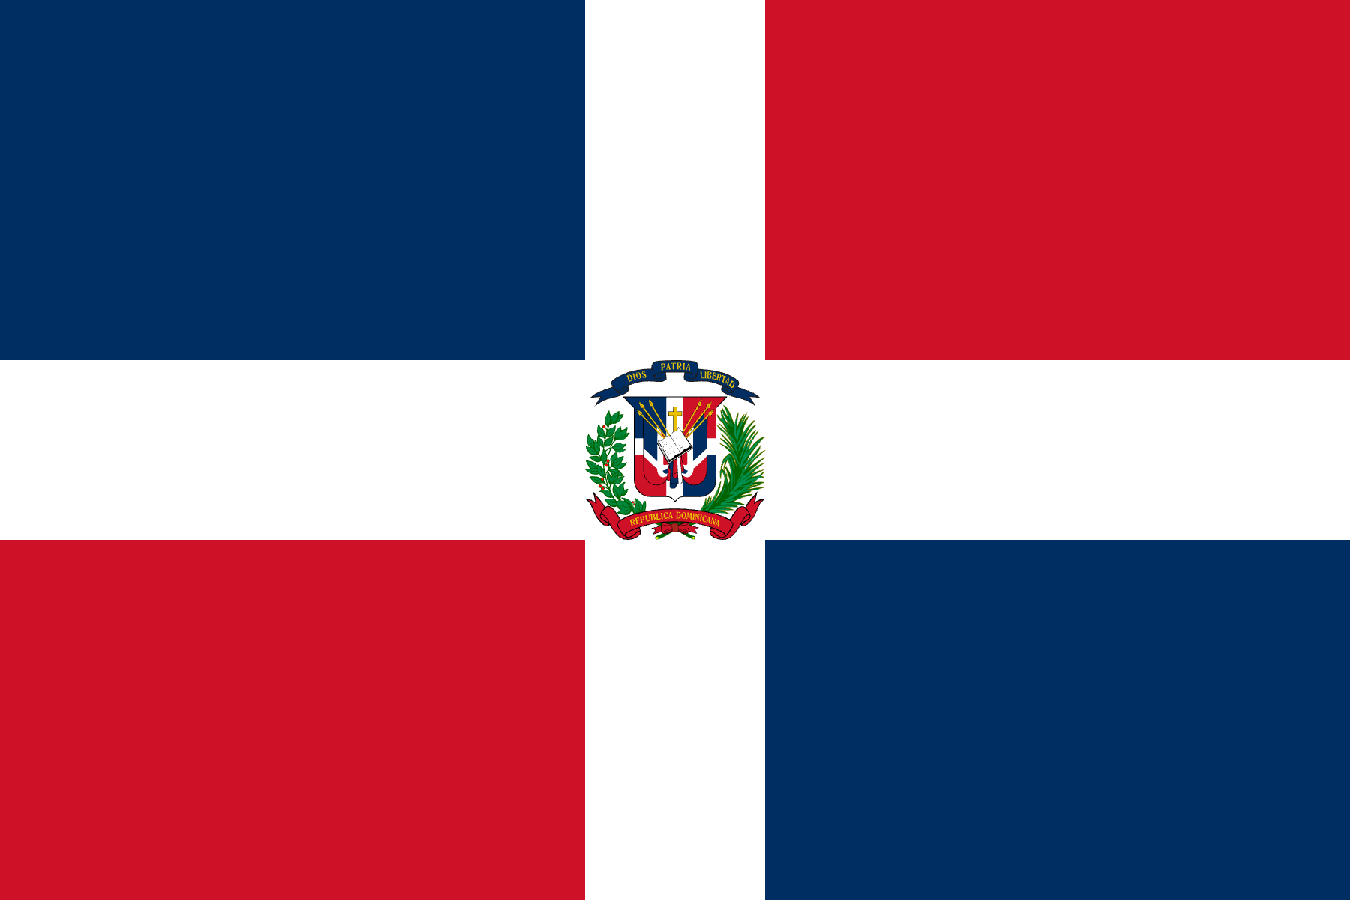
Committee: SPECPOL (Special Political and Decolonization
Committee)
Country: Dominican Republic
Agenda item: Reassessing the Political Status of
Disputed and Non-Self-Governing Territories

The Dominican Republic is located in the east of Hispaniola in the greater Antilles of the Caribbean sea, bordering the Republic of Haiti.The Dominican Republic covers an area of 48,671 square kilometers with a population of 10,7 million people. The official language of st country in terms of land. Even though the Dominican Republic is one of the smaller countries globally, the Dominican culture is extremely rich due to the country having many inhabitants live in their countries area for a long time. With the culture being a mixture of Spaniard colonists, African slaves and Taino natives culture.

A nation’s traditions and historical experiences reflect its political identity, and the Dominican Republic has endured significant challenges throughout its history. From repeated colonization attempts to slavery and the genocide of the Taíno people, the country itself was once a non-self-governing territory. In 1844, following a long struggle for freedom, the Dominican Republic declared independence and established a sovereign state. While acknowledging the progress achieved, the Dominican Republic also recognizes the profound human cost of colonialism, including the loss of indigenous lives and the suffering caused by forced labor systems. Guided by these historical lessons, the Dominican Republic firmly believes that for future societies to thrive, all peoples must be granted the protection of international law, respect for their cultural identity, and the right to determine their own political status.

To conclude, The Dominican Republic recognizes that even if these Disputed and Non-Self-Governing Territories are what Big countries take benefit from, they should have a respected political status as they are the ones that keep the world culture alive and not fall against toxic capitalism.

BİBLİOGRAPHY

https://en.wikipedia.org/wiki/Dominican_Republic

https://www.bbc.com/news/world-latin-america-19246340

https://en.wikipedia.org/wiki/History_of_the_Dominican_Republic

https://www.idea.int/democracytracker/country/dominican-republic

