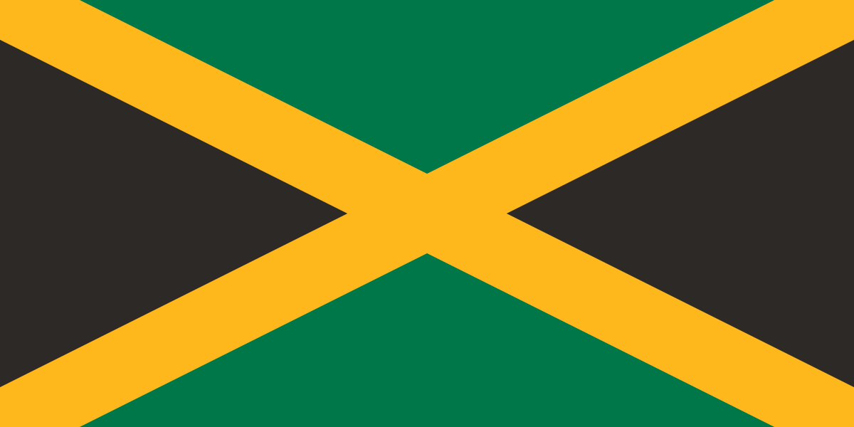
Committee:UNWOMEN
Country:Jamaica
Agenda Item: Strengthening protections around
women’s fundamental rights in the MENA region

Jamaica is a country located in the Caribbean, and it is the 3rd largest country in the Caribbean, coming after Cuba and Hispaniola. The island country has 10,990km2 of land. The country declared independence from Britain in 1962 and is still a member of the British Commonwealth. The current king of the country is Charles III, and the current president of the country is Andrew Hollness. Jamaica has a population of 2,8 million, while the gender ratio of the country is 1.44 million females and 1.4 million males. Jamaica is currently a member of the United Nations(UN), Organisation of American States(OAS), Caribbean Community(CARICOM), Association of Caribbean States(ACS), and lastly Non-Aligned Movement(NAM). Jamaica has the 76th best economy in the world, and the main economic resources of the country are aluminum and bauxite, which account for one-third of the country's export earnings, agricultural products, beverages, and tobacco. It is the main trading partner of the United States of America(USA). The currency of the country is the Jamaican dollar.

Women's rights have gotten to a point where they are decreasing every day. Unfortunately, in some regions, these problems still happen, and countries are refusing to take action on this problem. Jamaica has taken serious action in women's rights in the past couple of years, like the UNWOMEN Strategic Plan that covers America and Caribbean countries, and also one of the countries that accepted the Beijing Declaration and the Platform for Action. Even though women's rights were a problem in Jamaica in the past, Jamaica is taking its lesson by improving political representation and increasing the percentage of women in parliamentary seats to 28%. Also, 60% of the university graduates are women, so this means that Jamaica has improved in giving chances to women in education as well. Another proof of Jamaica making progress in women's rights is ranking 42nd place out of 153 countries by making significant progress in women's rights. However, work still needs to be done in Jamaica to achieve gender equality. 77.8% of legal frameworks that promote, enforce, and monitor gender equality under the SDG indicator, with a focus on violence against women, are in place.

Jamaica firmly believes that women and young girls should not be mistreated in society nor laws.Jamaica proposes a idea of helping countries who are strugling with the co-operation of the other Un committees such as Social,Humanitarian & Cultural Committee(SOCHUM),UN-HABITAT,The Economic & Social Council(ECOSOC) and Unicef espacially across MENA region.With the help of Unicef a lot of young girls would have the chance to have education or saving young girls from child marriage.With the help of the other countries to make laws that protects the rights of these women and girls .

BIBLIOGRAPHY
https://en.wikipedia.org/wiki/Jamaica
https://www.worldometers.info/world-population/jamaica-population/
https://atlas.hks.harvard.edu/countries/388/None
https://imuna.org/resources/country-profiles/jamaica/
https://www.statista.com/statistics/791111/population-total-gender-jamaica/#:~:text=In%202024%2C%20the%20total%20population,least%20since%202008%20to%202021.
https://www.britannica.com/place/Jamaica/Economy
https://www.unwomen.org/sites/default/files/Headquarters/Attachments/Sections/Library/Publications/2021/UN-Women-Strategic-Plan-2022-2025-brochure-en.pdf
https://jamaica.un.org/en/296936-accelerating-rights-equality-and-empowerment-all-women-and-girls
https://jamaica.un.org/en/296936-accelerating-rights-equality-and-empowerment-all-women-and-girls#:~:text=Political%20representation%20has%20also%20improved,Discrimination%20Against%20Women%20(CEDAW)
https://data.unwomen.org/country/jamaica

