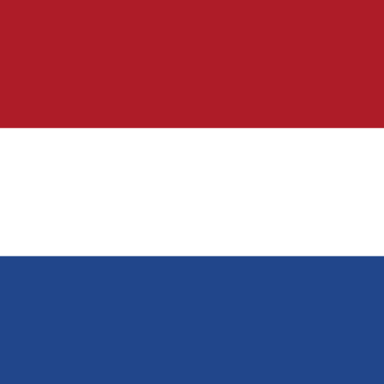 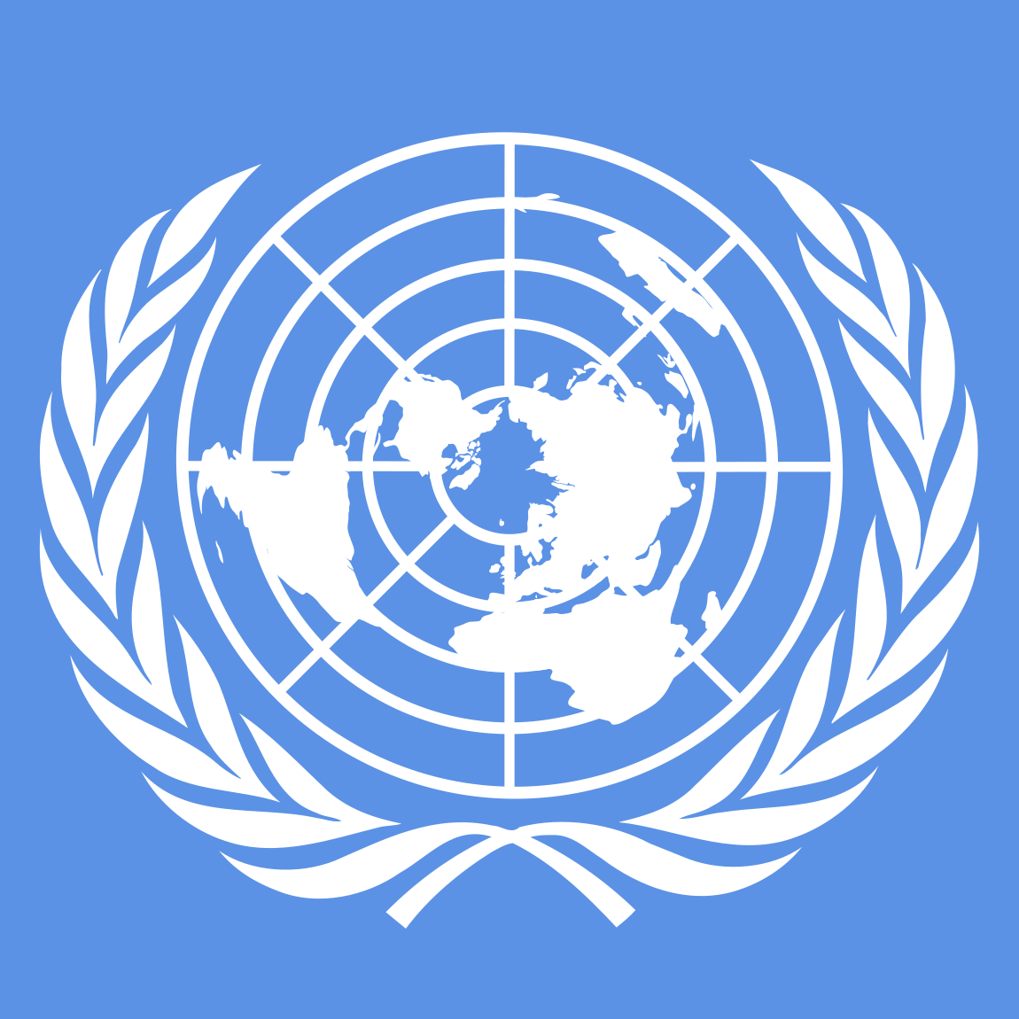   
Economic and Social Council (ECOSOC)  
  
Country: The Kingdom of Netherlands  
Agenda Item: Economic Policies Supporting Sustainable Development  
  
The Netherlands, informally Holland, is a country in Northwestern Europe, with overseas territories in the Carribean. It is the largest of the four constituent countries of the Kingdom of the Netherlands. The Netherlands consists of twelve provinces; it borders Germany to the east and Belgium to the south, with a North Sea coastline to the north and west. It shares maritime borders with the United Kingdom, Germany, and Belgium. The official language is Dutch, with West Frisian as a secondary official language in the province of Friesland. Dutch, English, and Papiamento are official in the Caribbean territories.  
  
The Netherlands falls into the (top 10) upper-middle ranks in economic sustainability with the country having a circularly stable economy, spending the currency evenly. This circular economy comes from investments, evenly spreading the funds, having programs that are predicted to last 40 years such as ”Amsterdam Circular” program. Netherlands also relies on using waste management plans and recycling to save the environment. We can see that these projects have had a positive impact on the country over a 15-year period (starting from the 1990’s). In the 17 goals of sustainability for the United Nations, in response for the ”Sustainable Communities and Cities”, Netherlands implemented a program called ”The Green Village”, using research centers to make this goal possible, reaching with projects from: circularity, water, renewable energy, buildings, intelligent outdoor spaces and smart mobility.  
  
Our suggestions and policy are mainly this way, proposing the UN to implement such facilities to be built and research to achieve the ideal and better conditions. We think that shifting the funds given in favor of research is better than trying to solve any problem with primitive methods. We saw that, with help; saving the day wouldn’t be any better than working for tomorrow. Our aim in this reunification is to mainly promote circularity in economy, research, recycling and investment while keeping stability for other subjects. We expect from the ECOSOC to be in favor of these ideas and understand that these solutions would impact the future.  
  
<https://www.sgi-network.org/2024/The_Netherlands/Economic_Sustainability><https://www.ams-institute.org/entrepreneurship/amsterdam-circular/><https://www.tudelft.nl/innovatie-impact/home-of-innovation/special/the-green-village>