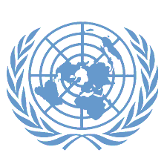

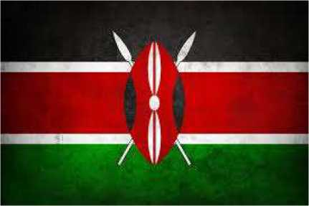Conference: LIVJMUN24

Committee: UNFCCC

Topic: INCREASING THE USAGE OF RENEWABLE ENERGY IN DEVELOPING COUNTRIES

Country: KENYA

Delegate: ELİF BUĞLEM İSTANBUL

Kenya, officially the Republic of Kenya, is a country in the eastern part of the African continent. The country's border neighbors: Ethiopia, Somalia, Tanzania, Uganda and South Sudan, some of which border Lake Victoria. Apart from this, the Indian Ocean is located in the southeast of the country. The capital and largest city of the country is Nairobi. The climate of the country is generally divided into two parts. In the highlands of Kenya, which exceed 1,800 m in altitude, heavy rains can be observed in April-June and October-November. These rains usually fall during the afternoon, evening and night periods of the day, and the nights can be quite cool. The coldest periods in these regions are July and August, with daily lows of 10 °C. January and February are the hottest months, with daily highs of 25 to 26 °C.

Kenya has made significant progress in the development and utilization of renewable energy sources over the past 50 years. The country has become a regional leader in renewable energy, with a focus on expanding access to clean energy, improving energy security, and addressing climate change. Kenya generates around 90% of its electricity from renewable energy, but has a target of 100%.One of the most notable projects in Kenya’s wind energy sector is the Lake Turkana Wind Power Project. This is the largest wind power project in East Africa, with a capacity of 310 MW. Kenya has integrated renewable energy into its broader climate change and adaptation strategy.Nationally Determined Contributions (NDCs): Kenya has committed to reducing its greenhouse gas emissions through its NDCs under the Paris Agreement. The country aims to increase the share of renewable energy in its energy mix, reduce reliance on fossil fuels, and improve energy efficiency as part of its climate action plan.

Kenya has enacted several policies and regulations that support the growth of renewable energy like Kenya Vision 2030. As part of the country’s long-term development plan, Kenya Vision 2030, the government has emphasized the role of renewable energy in achieving sustainable development. The vision aims to provide clean, affordable, and reliable energy to all citizens by 2030. The UN can assist Kenya by Providing Technical and Financial Assistance: Through agencies like the UN Development Programme (UNDP) and the World Bank, the UN can offer funding, technical expertise, and capacity-building support for renewable energy projects. This could include expanding solar and wind power infrastructure, enhancing geothermal production, and promoting energy efficiency measures.