Country: Turkey
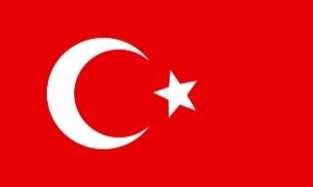

Committee: World Health Organization (WHO)

Topic: Addressing Health Issues Caused by Air Pollution

The World Health Organization is instrumental to the world in protecting the public’s health through the prevention of illnesses, promoting healthy environments, and strengthening health systems globally. Turkey, located on the borders of Europe and Asia experiences rapid urban growth, population growth, and industrial development. While these factors aid in the economic development of the country, they also pose stingeing public environmental and health challenges such as the air pollution that is evident and directly compromise the health of our people.

A factor that matters to us and is a worldwide issue is air pollution. In Türkiye, harmful and cheap fuel utilization, high levels of vehicle emissions, traffic jam, improper heating systems (coal-wood stoves), emissions from the industry and factories, mismanagement of industrial waste, fossil fuel overconsumption and its chemical variants, pesticides, and population growth, unplanned urbanization, and reduced afforestation (the along with many other) contribute to high levels of air pollution. These factors aggravate the prevalence of illnesses that affect the respiratory and cardiovascular systems and hence add a burden to the Health Care Systems and the public.

We are certain that balance policies at the national level and international collaboration is the foundation for real answers. Türkiye advocates for the adoption of clean and appropriate fuels, source-based control of pollution, effective waste management and filtration systems in industries. The promotion of renewable energy, enhancement of public transport, reduction of the use of private cars, tightening emission control, better insulation of buildings, increased greenery, education of people and public awareness are all essential actions. Together with the World Health Organization and the Member States, we will do our best to control the level of air pollution and protect the health of the population.

References:

https://eurohealthobservatory.who.int/publications/i/health-systems-in-action-t%C3%BCrkiye- 2022
https://www.niehs.nih.gov/health/topics/agents/air-pollution
https://www.who.int/teams/environment-climate-change-and-health/air-quality-energy-and- health/health-impacts

