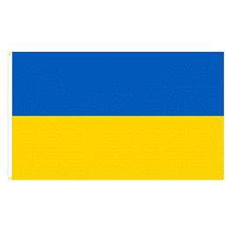
Committee: UNICEF,EUROPEAN COMMİSSİON EACEA
Topic: Ensuring Refuge Children Have Access to Education

Ukraine is a big country in Eastern Europe and the capital city of Ukraine is Kyiv.According to do latest data for 2025,Ukraine’s population is 39.463.624.The education system in Ukraine is organized into five levels:preschool,primary school,high school,university and post graduate education.It has a really old history and culture,and they grow lots of food on their great land.Even tough Ukraine has had a lot of hard problems lately because of the war,the government always says that school is super important.They believe every kid has the right to g oto school,and they work with big groups like the United Nations to try and protect that right.
The European Union Council adopted the directive on providing temporary protection to refugees from Ukraine on 4 March 2022.In particular,Access to education was recognized as an urgent priority for the integration and well-being of Ukrainian children and youth.European countries have taken many measures to help children and young people access schools.However,they have faced some challenges that could hinder school integration.Language barriers,lack of documentation anf families’ reluctance to enroll their children in local schools.These are some of the obstacles preveting Ukrainian students from participating in education.
In addition to access to local schools,Ukrainian students could be offered support in accessing distance learning based on the Ukrainian education system and curriculum,or in attending specific classes exclusively for students from Ukraine.To beter respond to students needs,Europen Education systems can cooperate with Ukrainian teachers and benetit from their expertise and language skills.Another possibility is for Ukranian students to follow their national curriculum online.

REFERENCES:
UNICEF. Education in Emergencies: Ukraine Response. UNICEF Reports, 2023.
UNHCR. Access to Education for Refugee Children. UNHCR Publications, 2023.
UNESCO. Education for Displaced and Refugee Learners. UNESCO Briefings, 2022.
European Commission. EU Support for the Education of Ukrainian Refugee Children. EC Official Report, 2023.

