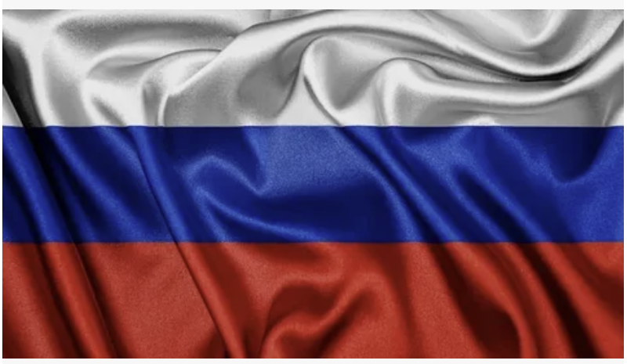
Country: Russia
Committee: UN-HABITAT
Topic: Building Sustainable and Smart Cities of the Future

Russia or the Russian Federation is a country in Eastern Europe and North Asia. It is the largest country in the world. With a population of over 140 million, Russia is the most populous country Europe and the ninth most populous county in the world. It is a highly urbanised country with sixteen of its urban areas having more than 1 million inhabitants. Moseow is the capital city of Russia.
Kaluga, Russia 15 March 2019-UN-habitat and the Ministry of Construction Housing and Utilities Sector of the Russian Federation (ministroy), the Kaluga Region Government, and a non-profit organization digital economy have jointly convened an international forumon Smart City; Application guide in the Russian city of Kaluga. The Executive Director of UN-habitat, Ms. Maimunah Mohd Sharif said the Smart City concept contributes greatly to implementation of the 2030 Agenda for Sustainable Development and the New Urban Agenda.’’Only with new ideas and new digital Technologies can we find solutions to major urban challenges.’’
The Development of smart cities is a clear growing trend all around the world. The convergence of different technological, social, political, economical and ecological trends has allowed the concepts to rise up quickly in governmental agendas. In this paper, we analyze the situation of Russia regarding smart cities. Moscow, Saint Petersburg, and Kazan are considered at the “Smart City 3.0’’ stage of Development, meaning that the citizens are participating in their advancement. Our reasons to focus on Russia are two-fold (1) we know the situation well, as we live and work in a new city, Innopolis, founded in 2015 and meant to be a blueprint for smart cities; (2) large Russian cities are actively developing projects in this sphere and are highly regarded worldwide in these endeavors.

References:
hptts://unhabitat.org
hptts://www.researchgate.net

