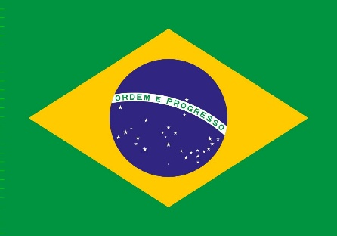
Country: Brazil
Comittee: SPECPOL
Agenda Item: Reconstruction and Development In Post-Conflict Regions
Federative Republic Of Brazil covers South America's 47%. The biggest and the most crowded country of South America. Not only the biggest and the most crowded country of South America but one of the biggest coutries on the world as well. The most crowded city in Brazil is São Paulo. The population of Brazil is 211,1 million. It has 26 states and one federal place. Official language in Brazil is Portuguese. Brazil uses it's own official currency called Brazillian real (BRL and showed like R$). Brazil’s top exports are soybeans (14%), petroleum oils (13%), and iron (8%), mainly shipped to China (27%), the United States (11%), and Argentina (5%). Key imports include crude oil (6%), petroleum oils (4%), and potassium chloride (3%), an essential input for agriculture. Brazil imports primarily from China (22%), the United States (9%), and Argentina and Germany (5%), totaling USD 272.6 billion. Agriculture remains Brazil’s leading economic sector, with coffee, soybeans, and other major crops driving production.
Post-conflicts are big problems for world. But after post-conflicts countries have to develop again. For reconstruction and development in post-conflict regions we can say that increasing agriculture productivity, improving the work environment, strengthen education, getting ahead of deforestation and equality for everyone, is some of the important articles. In post-conlflict regions people are trying to found peace. It is so serious and important and UN has to find some solutions for reconstruction and development in post-conflict regions. Brazil is developing and working to solve it. For Brazil’s place in reconstruction, we can say that their providing significant support to Syria. Brazil gives a chance for people who are affected from Syria crisis. Brazil helps them to making a life there. There are articles and speeches confirming that UNHCR played an important role for Brazil in the global refugee crisis. That shows Brazil plays a big role in reconstruction and development in post-conflict regions.
Brazil gives importance continuously for agriculture and trade. Brazil believes that developments in production and technology will greatly benefit restructuring. Brazil believes that increasing the competitiveness of the Brazilian industry also plays an important role. In the field of health, Brazil thinks that medicines, vaccines and medical devices should be provided. Brazil belives that improving the business environment will increase the wellfare of people.
References:
https://tr.m.wikipedia.org/wiki/Brezilya
https://www.google.com/url?sa=t&source=web&rct=j&opi=89978449&url=https://ticaret.gov.tr/data/62c696dd13b876ae383fd792/Brezilya%2520Pazara%2520Giri%25C5%259F%2520Rehberi.pdf&ved=2ahUKEwi25Z7vkdiMAxUKRfEDHWrOIMwQFnoECCYQAQ&usg=AOvVaw0kEaH3uL_jlaHUhd_oh9F2
https://www.worldbank.org/en/country/brazil/overview
https://documents.worldbank.org/en/publication/documents-reports/documentdetail/268351520343354377/agriculture-productivity-growth-in-brazil-recent-trends-and-future-prospects
https://www.unhcr.org/news/stories/brazil-and-unhcr-strengthen-partnership-help-refugees-fleeing-syria-conflict
https://www.gov.br/secom/en/latest-news/2024/01/2023-was-marked-as-a-year-to-rebuild-brazilian-foreign-policy

